**EC-210**

**Microprocessors Lab**

**LAB-3**



Utkarsh Mahajan 201EC164

ARNAV RAJ 201EC109

Objective: To demonstrate the use of load and Store instructions and their addressing.

**Exercise:**

**3.2]** Write an assembly program to add two numbers: C = a+ b where

(a) a and b are both unsigned 32 bit numbers

(b) a and b are both signed 32 bit numbers

(c) a and b are both unsigned 64 bit numbers

(d) a and b are both signed 64 bit numbers

Load a and b from memory and store the results including carry into new location.

->

**(a) a and b are both unsigned 32 bit numbers**

We will take values from the memory and store it in R2 and R3. Then store the Calculated result in R0 and R4. This result is later stored in memory positioned after the input value memory locations.

Source Code:

    AREA qthreetwo, CODE, READONLY

    EXPORT Reset_Handler

Reset_Handler

Start MOV R1, #0x40000000*; Address of the memory where the*

*; number is present*

    MOV R0, #0 *; R0 holds the result*

Loop LDR R2, [R1], #4 *; Load the first number & advance ptr*

    LDR R3, [R1], #4 *; Load the second number & advance ptr*

    ADDS R0, R2, R3 *; Add the numbers*

    ADC R4, #0*;*

    STR R0, [R1], #4 *; store the result in the next memory*

    STRB R4, [R1], #4 *; store the carry result in the next memory*

Stop B Stop

    END

Debugging:

Initial Memory:

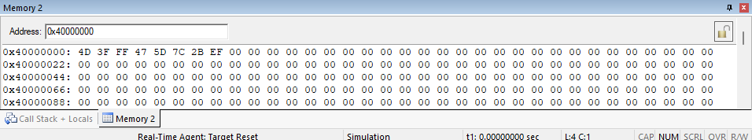

Setup:

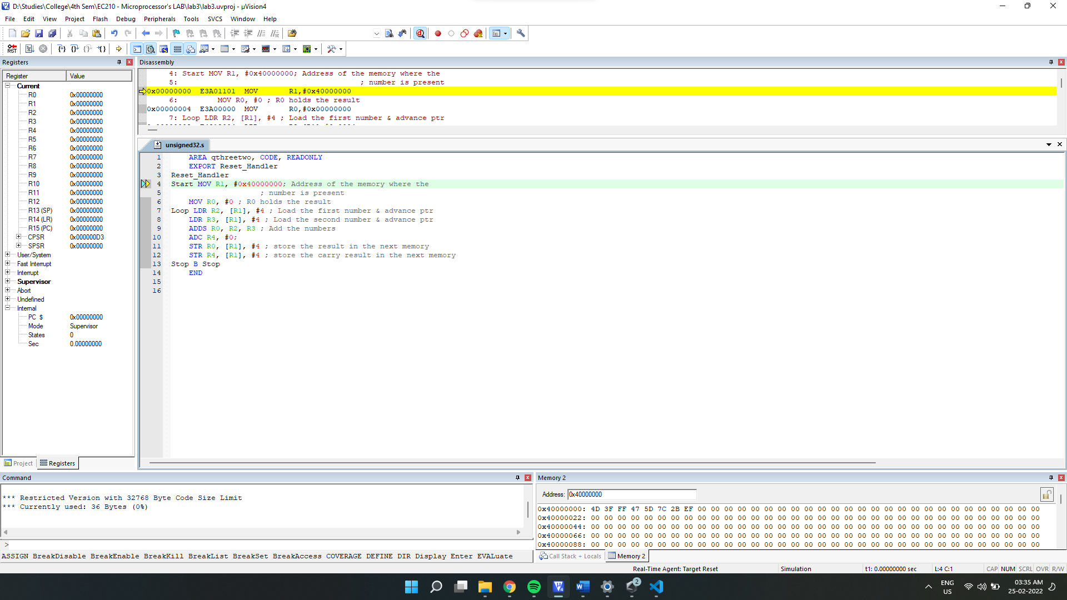

After Execution:

Final Output:

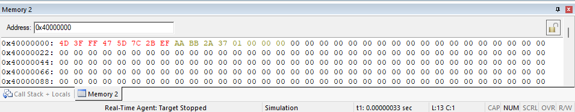

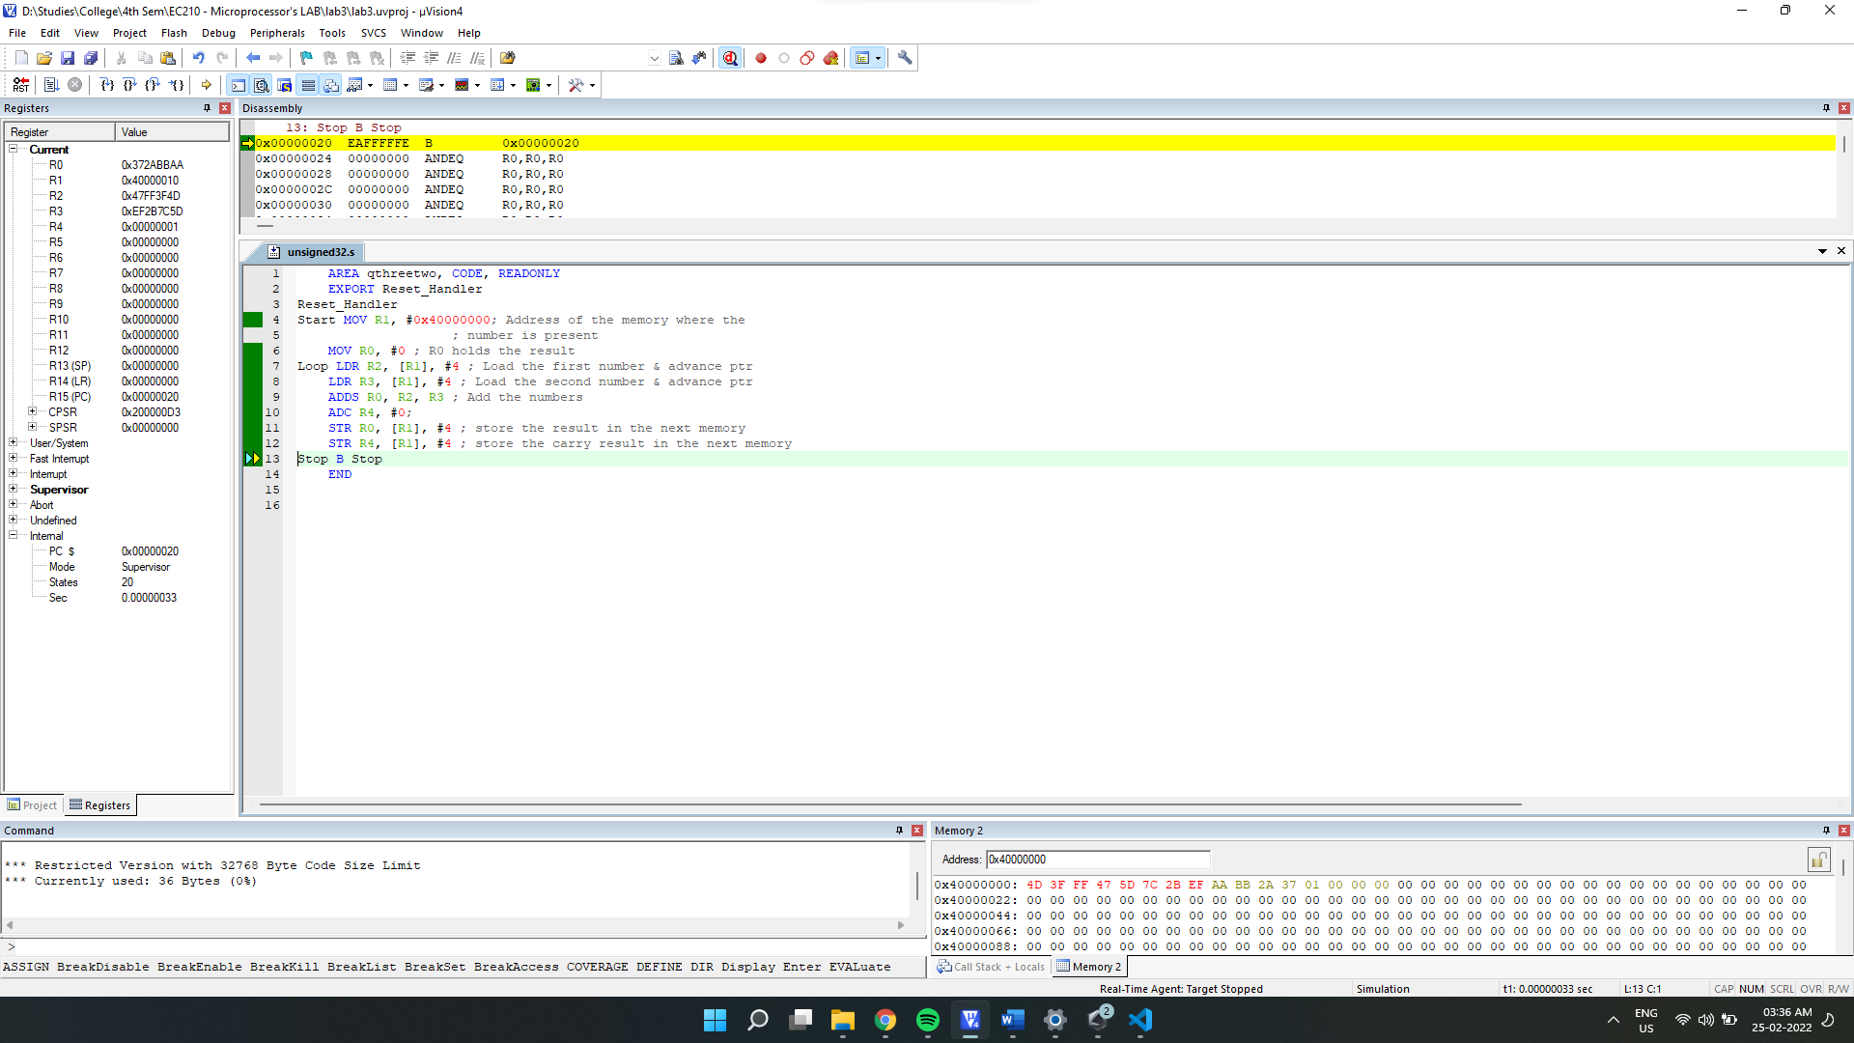

Final Register Values:

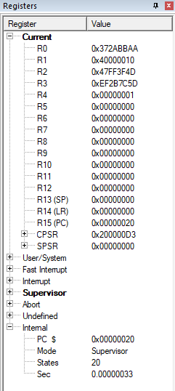

**(b) a and b are both signed 32 bit numbers**

We will take values from the memory and store it in R2 and R3. While calculating addition in signed numbers, we know that we need to consider N(Negative) as the additional bit if overflow V=0 otherwise C(carry) for the **additional** bit. We will handle this by appending **conditional execution** code **VC**. Then store the Calculated result in R0 and R4. This result is later **stored in memory** locations positioned after the input value memory locations.

Source code

    AREA qthreetwo, CODE, READONLY

    EXPORT Reset_Handler

Reset_Handler

Start MOV R1, #0x40000000*; Address of the memory where the*

*; number is present*

    MOV R0, #0 *; R0 holds the result*

Loop LDR R2, [R1], #4 *; Load the first number -1 & advance ptr*

    LDR R3, [R1], #4 *; Load the second number -2 & advance ptr*

    ADDS R0, R2, R3 *; Add the numbers*

    MRSVC R5, CPSR*; using N as additional bit if V==0*

    LSLSVC R5, #1*; otherwise set C as the additional bit*

    ADC R4, #0*;The additional bit.*

    STR R0, [R1], #4 *; store the result in the next memory*

    STR R4, [R1], #1 *; store the carry result in the next memory*

Stop B Stop

    END

Debugging:

Initial Memory:

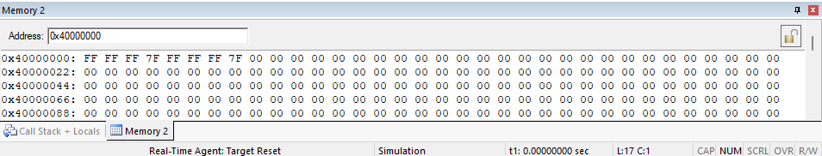

Setup:

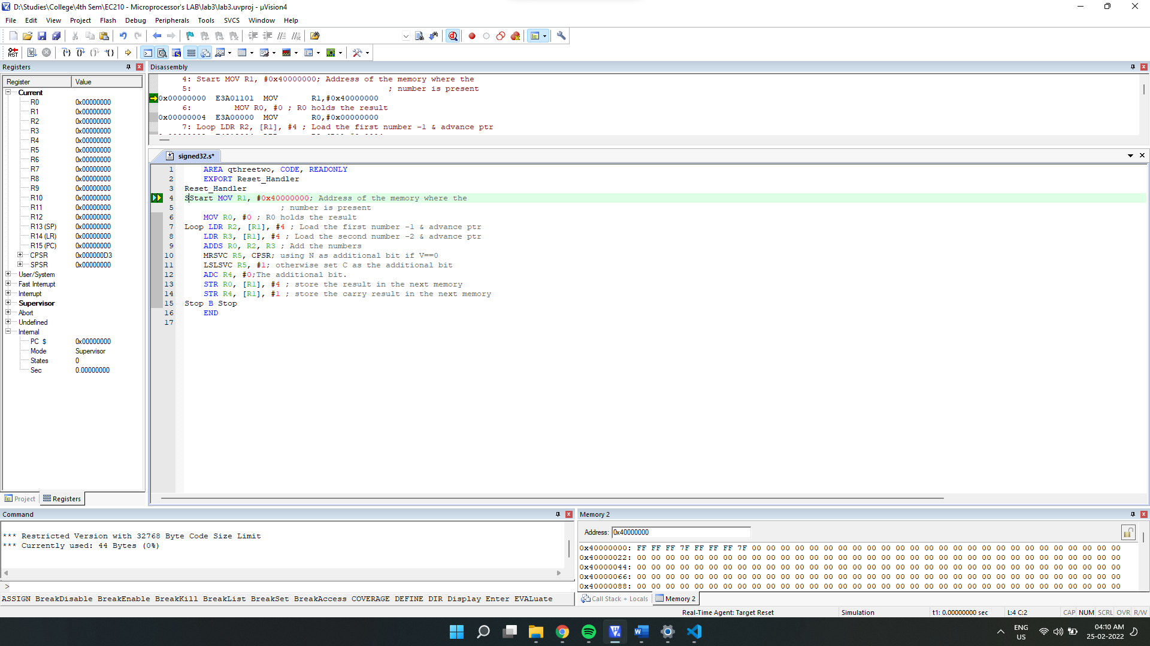

After Execution:

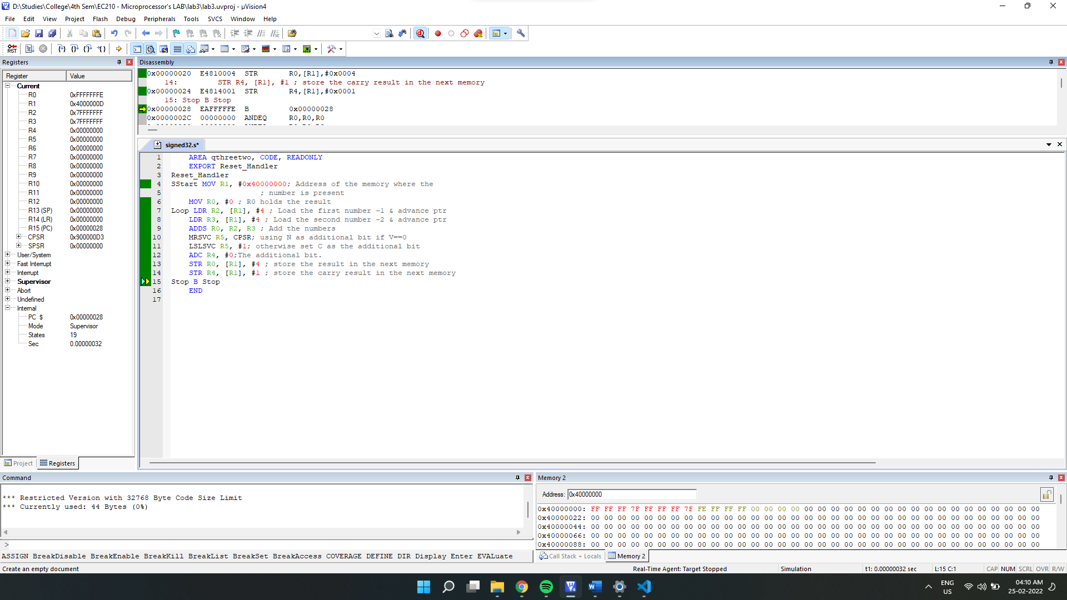

Final memory Output:

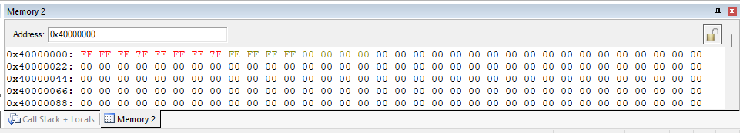

Final Register Values:

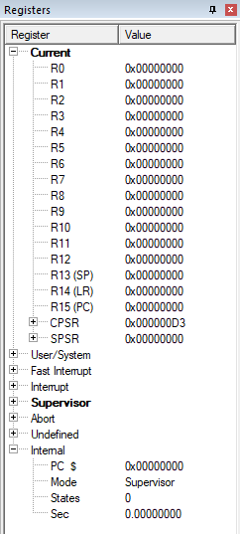

(c) a and b are both unsigned 64 bit numbers

We will take values from the memory and store it in R2, R3, R4 and R3. Then store the Calculated result in R6, R7 and R8. This result is later stored in memory positioned after the input value memory locations.

Source code:

    AREA qthreetwo, CODE, READONLY

    EXPORT Reset_Handler

Reset_Handler

Start MOV R1, #0x40000000*; Address of the memory where the*

*; number is present*

    MOV R6, #0 *; R4 and R5, R6 to hold  the result*

    MOV R7, #0 *;*

    MOV R8, #0 *;*

Loop LDR R2, [R1], #4 *; Load the first number's low & advance ptr*

    LDR R3, [R1], #4 *; Load the first number's high & advance ptr*

    LDR R4, [R1], #4 *; Load the second number's low & advance ptr*

    LDR R5, [R1], #4 *; Load the second number's high & advance ptr*

    ADDS R6, R4, R2 *; Add the numbers low*

    ADCS R7, R5, R3 *; Adding high of both numbers with carry from low add.*

    ADC R8, #0*;The additional bit.*

    STR R6, [R1], #4 *; store the Low result in the next memory*

    STR R7, [R1], #4 *; store the High result in the next memory*

    STR R8, [R1], #4 *; storing the carry in the next memory*

*; We have stored the result in 96bits(64 +32)*

Stop B Stop

    END

Debugging:

Initial Memory:

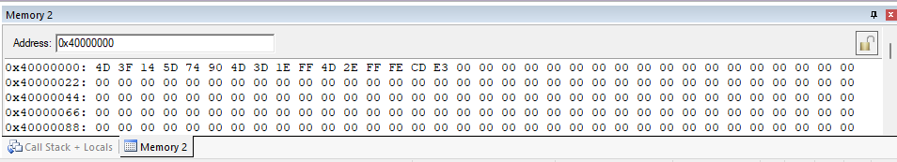

Setup:

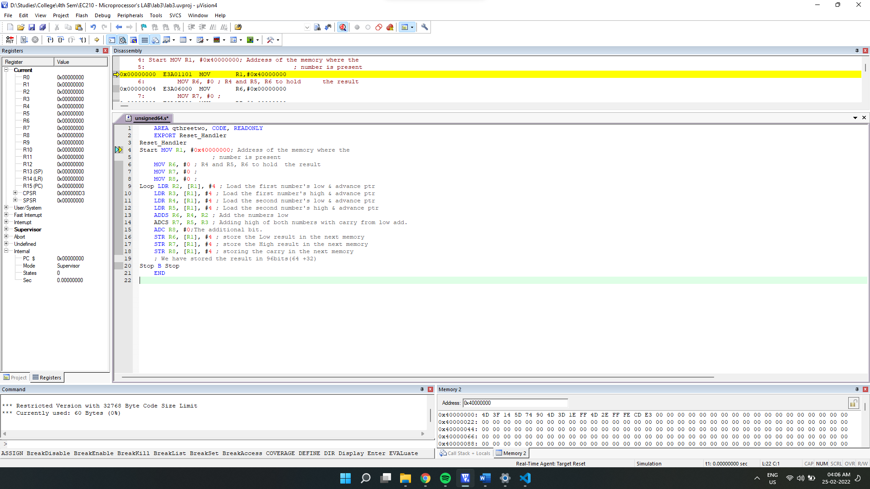

After Execution:

Final Output: 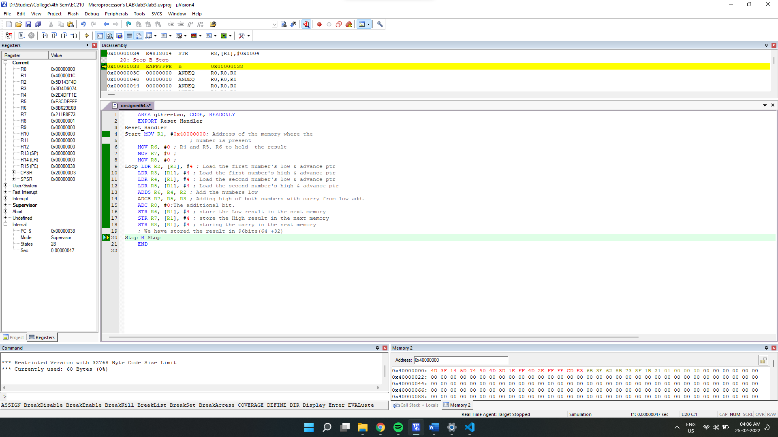

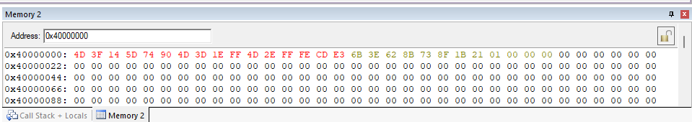

Final Register Values:

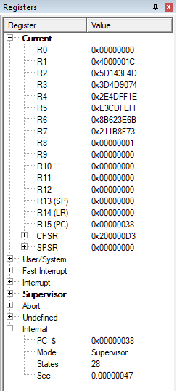

**(d) a and b are both signed 64 bit numbers**

We will take values from the memory and store it in R2 and R3. While calculating signed numbers, we know that we need to consider N(Negative) as the additional bit if overflow V=0 otherwise C(carry) for the **additional** bit. We will handle this by appending **conditional execution** code **VC**. Then store the Calculated result in R6, R7 and R8. This result is later **stored in memory** locations positioned after the input value memory locations. **65th bit will be sign**

Source code

    AREA qthreetwo, CODE, READONLY

    EXPORT Reset_Handler

Reset_Handler

Start MOV R1, #0x40000000*; Address of the memory where the*

*; number is present*

    MOV R6, #0 *; R4 and R5, R6 to hold  the result*

    MOV R7, #0 *;*

    MOV R8, #0 *;*

Loop LDR R2, [R1], #4 *; Load the first number's low & advance ptr*

    LDR R3, [R1], #4 *; Load the first number's high & advance ptr*

    LDR R4, [R1], #4 *; Load the second number's low & advance ptr*

    LDR R5, [R1], #4 *; Load the second number's high & advance ptr*

    ADDS R6, R4, R2 *; Add the numbers low*

    ADCS R7, R5, R3 *; Adding high of both numbers with carry from low add.*

    MRSVC R9, CPSR*; using N as additional bit if V==0*

    LSLSVC R9, #1*; otherwise set C as the additional bit*

    ADC R8, #0*;The additional bit.*

    STR R6, [R1], #4 *; store the Low result in the next memory*

    STR R7, [R1], #4 *; store the High result in the next memory*

    STR R8, [R1], #4 *; storing the carry in the next memory*

*; We have stored the 65 bit result in 96bits(64 +32).*

*; 65th bit will be sign.*

Stop B Stop

    END

Debugging:

Initial Memory:

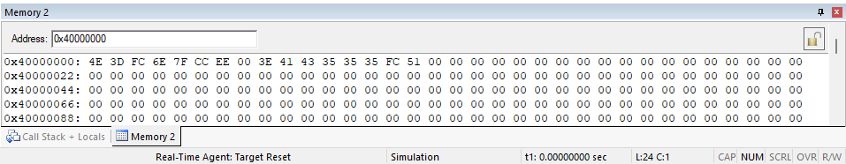

Setup:

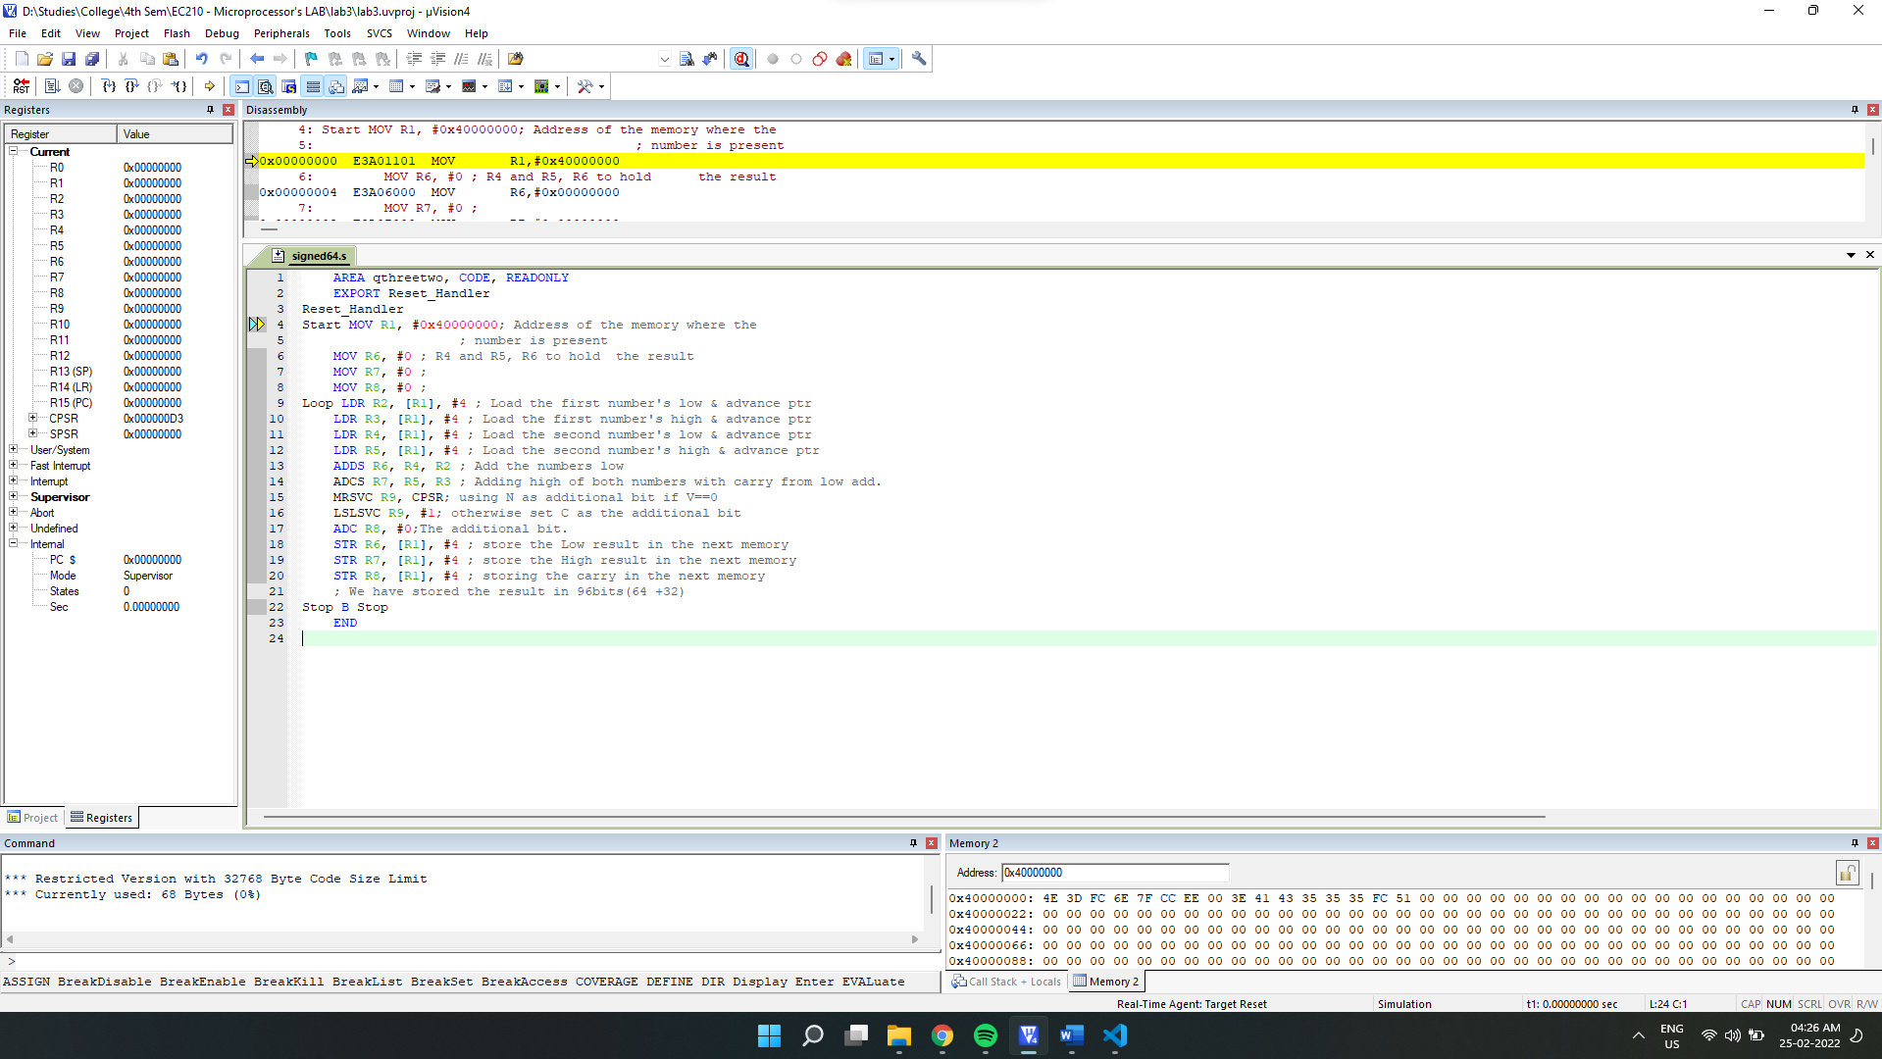

After Execution:

Final Output:

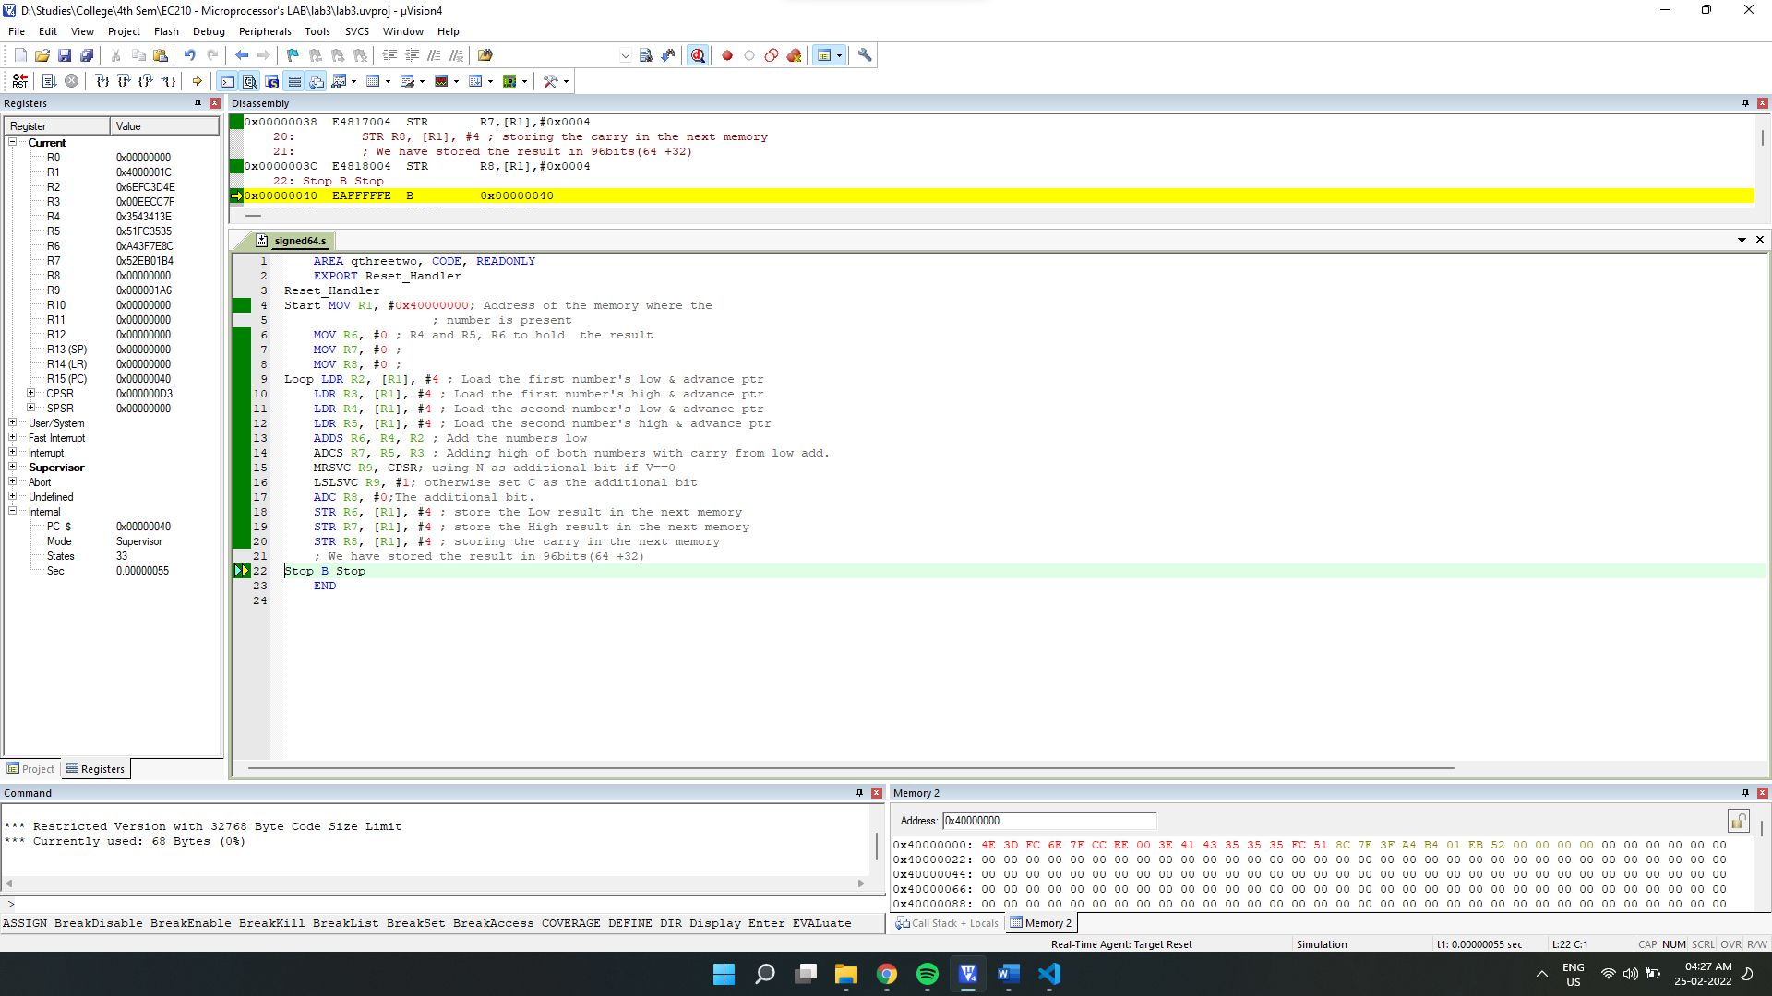

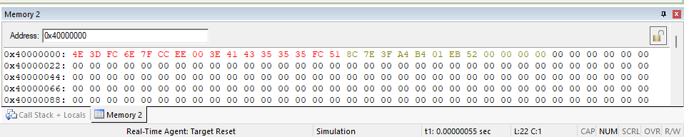

Final Register Values:

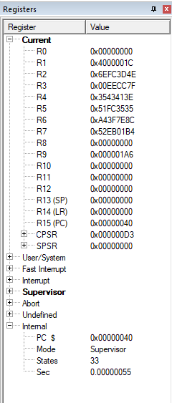

**3.3]** Write an assembly program to perform C = a – b where

(a) a and b are both unsigned 32 bit numbers

(b) a and b are both signed 32 bit numbers

(c) a and b are both unsigned 64 bit numbers

(d) a and b are both signed 64 bit numbers

->

**(a) a and b are both unsigned 32 bit numbers**

We will take values from the memory and store it in R2 and R3. Then store the Calculated result in R0 and R4. This result is later stored in memory positioned after the input value memory locations.

Source code:

    AREA qthreetwo, CODE, READONLY

    EXPORT Reset_Handler

Reset_Handler

Start MOV R1, #0x40000000*; Address of the memory where the*

*; number is present*

    MOV R0, #0 *; R0 holds the result*

Loop LDR R2, [R1], #4 *; Load the first number & advance ptr*

    LDR R3, [R1], #4 *; Load the second number & advance ptr*

    SUBS R0, R2, R3 *; Subtract the numbers*

    SBC R4, #0*;*

    STR R0, [R1], #4 *; store the result in the next memory*

    STRB R4, [R1], #4 *; store the carry result in the next memory*

Stop B Stop

    END

Debugging:

Initial Memory:

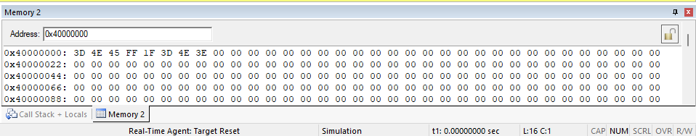

Setup:

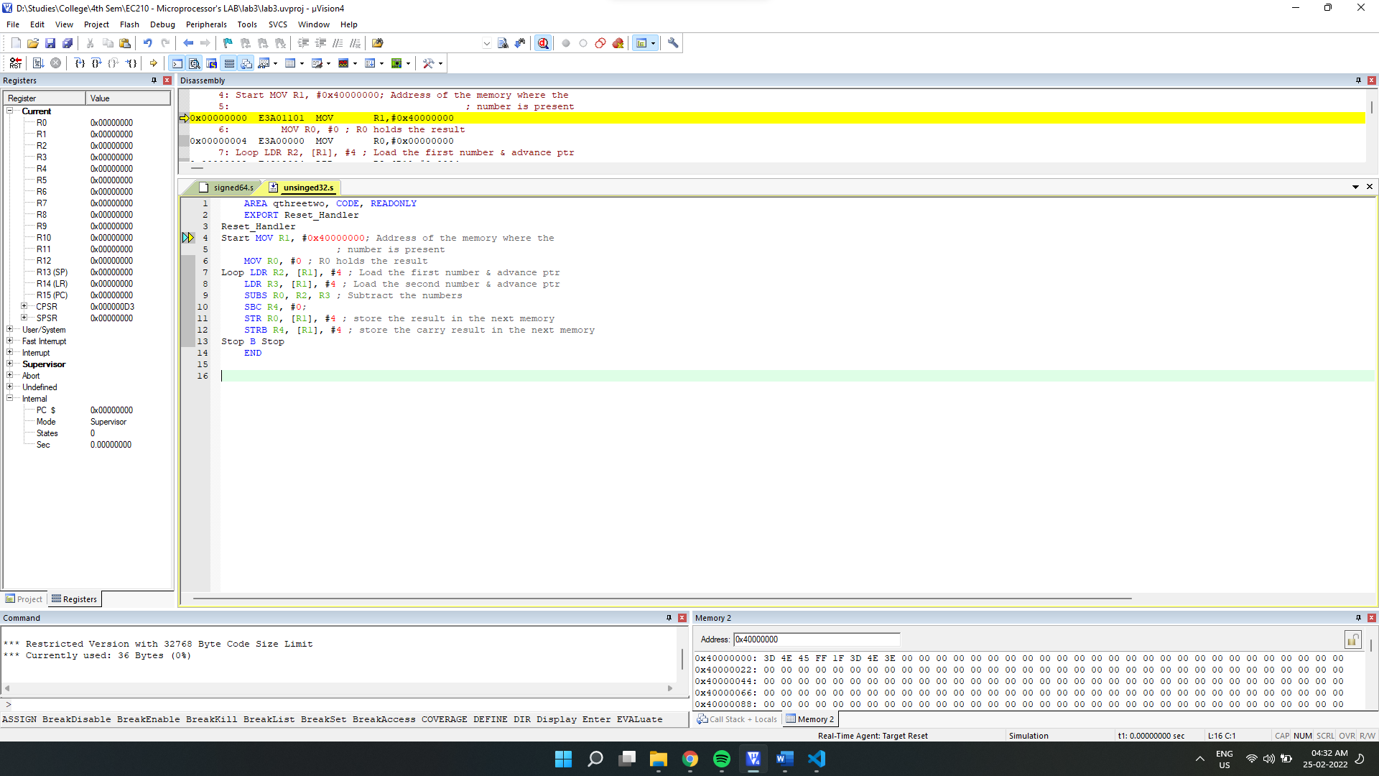

After Execution:

Final Output:

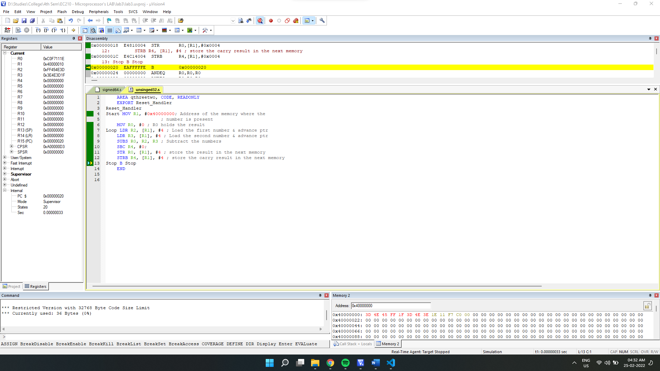

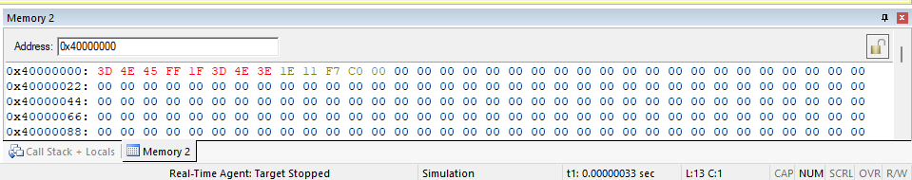

Final Register Values:

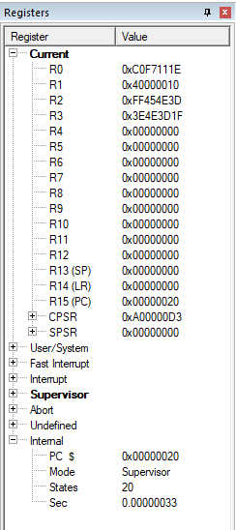

**(b) a and b are both signed 32 bit numbers**

We will take values from the memory and store it in R2 and R3. While calculating subtraction in signed numbers, we know that we need to consider N(Negative) as the additional bit if overflow V=0 otherwise C(carry) for the **additional** bit. We will handle this by appending **conditional execution** code **VC**. Then store the Calculated result in R0 and R4. This result is later **stored in memory** locations positioned after the input value memory locations.

Source code:

    AREA qthreetwo, CODE, READONLY

    EXPORT Reset_Handler

Reset_Handler

Start MOV R1, #0x40000000*; Address of the memory where the*

*; number is present*

    MOV R0, #0 *; R0 holds the result*

Loop LDR R2, [R1], #4 *; Load the first number -1 & advance ptr*

    LDR R3, [R1], #4 *; Load the second number -2 & advance ptr*

    SUBS R0, R2, R3 *; Add the numbers*

    MRSVC R5, CPSR*; using N as additional bit if V==0*

    LSLSVC R5, #1*; otherwise set C as the additional bit*

    ADC R4, #0*;The additional bit.*

    STR R0, [R1], #4 *; store the result in the next memory*

    STR R4, [R1], #1 *; store the carry result in the next memory*

Stop B Stop

    END

Debugging:

Initial Memory:

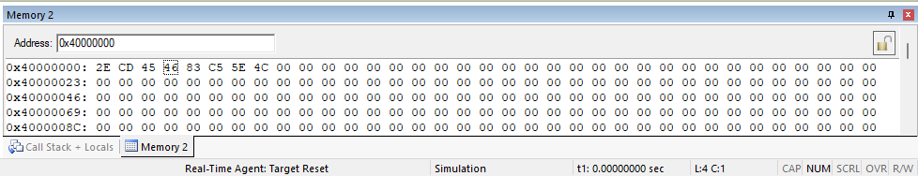

Setup:

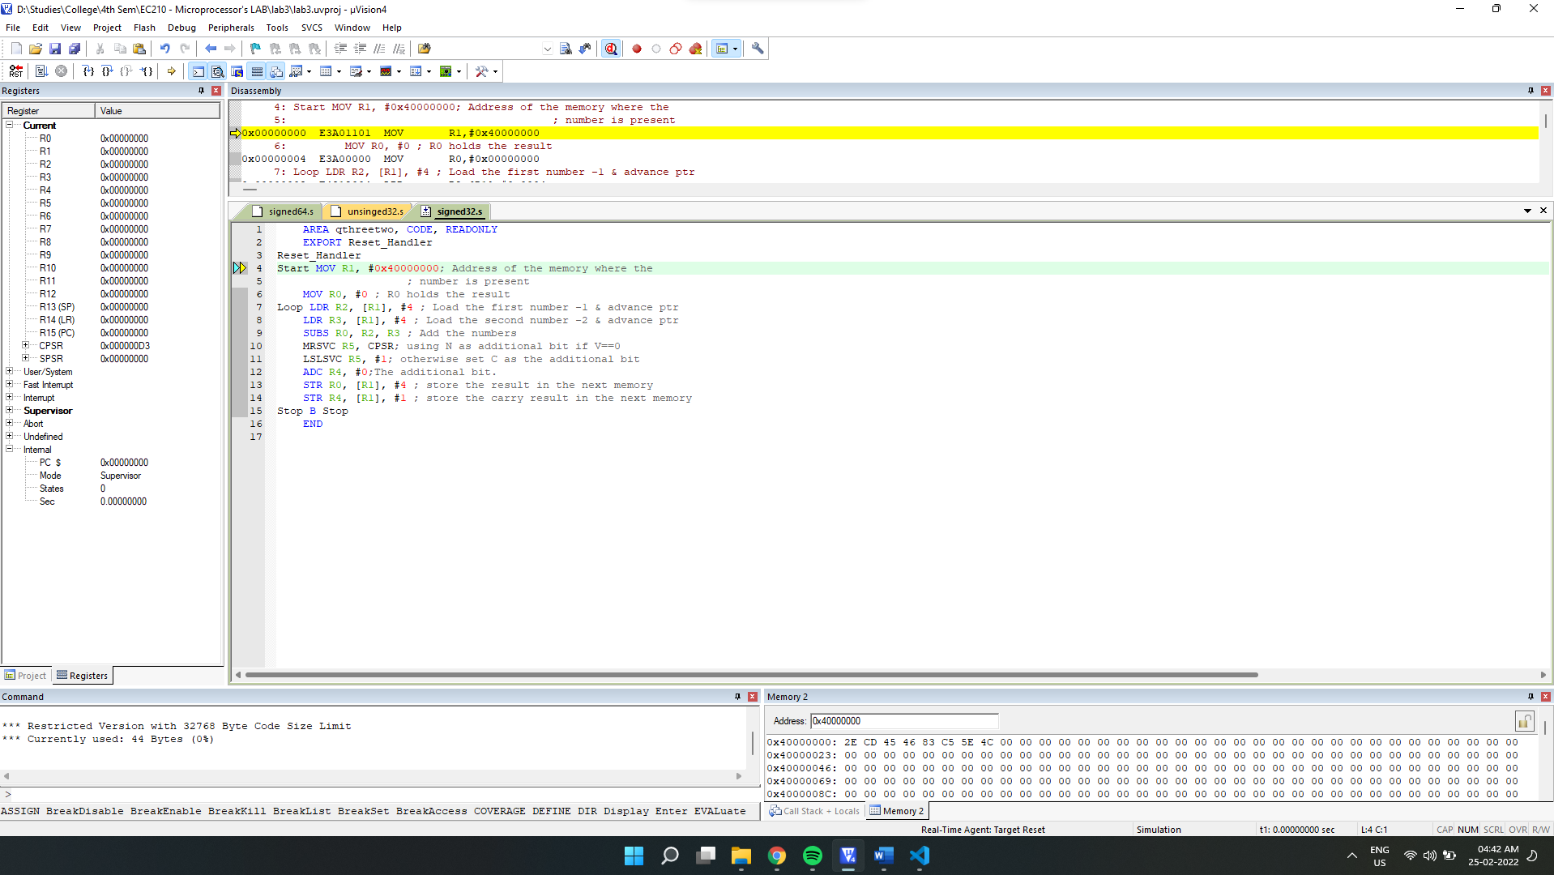

After Execution:

Final Output:

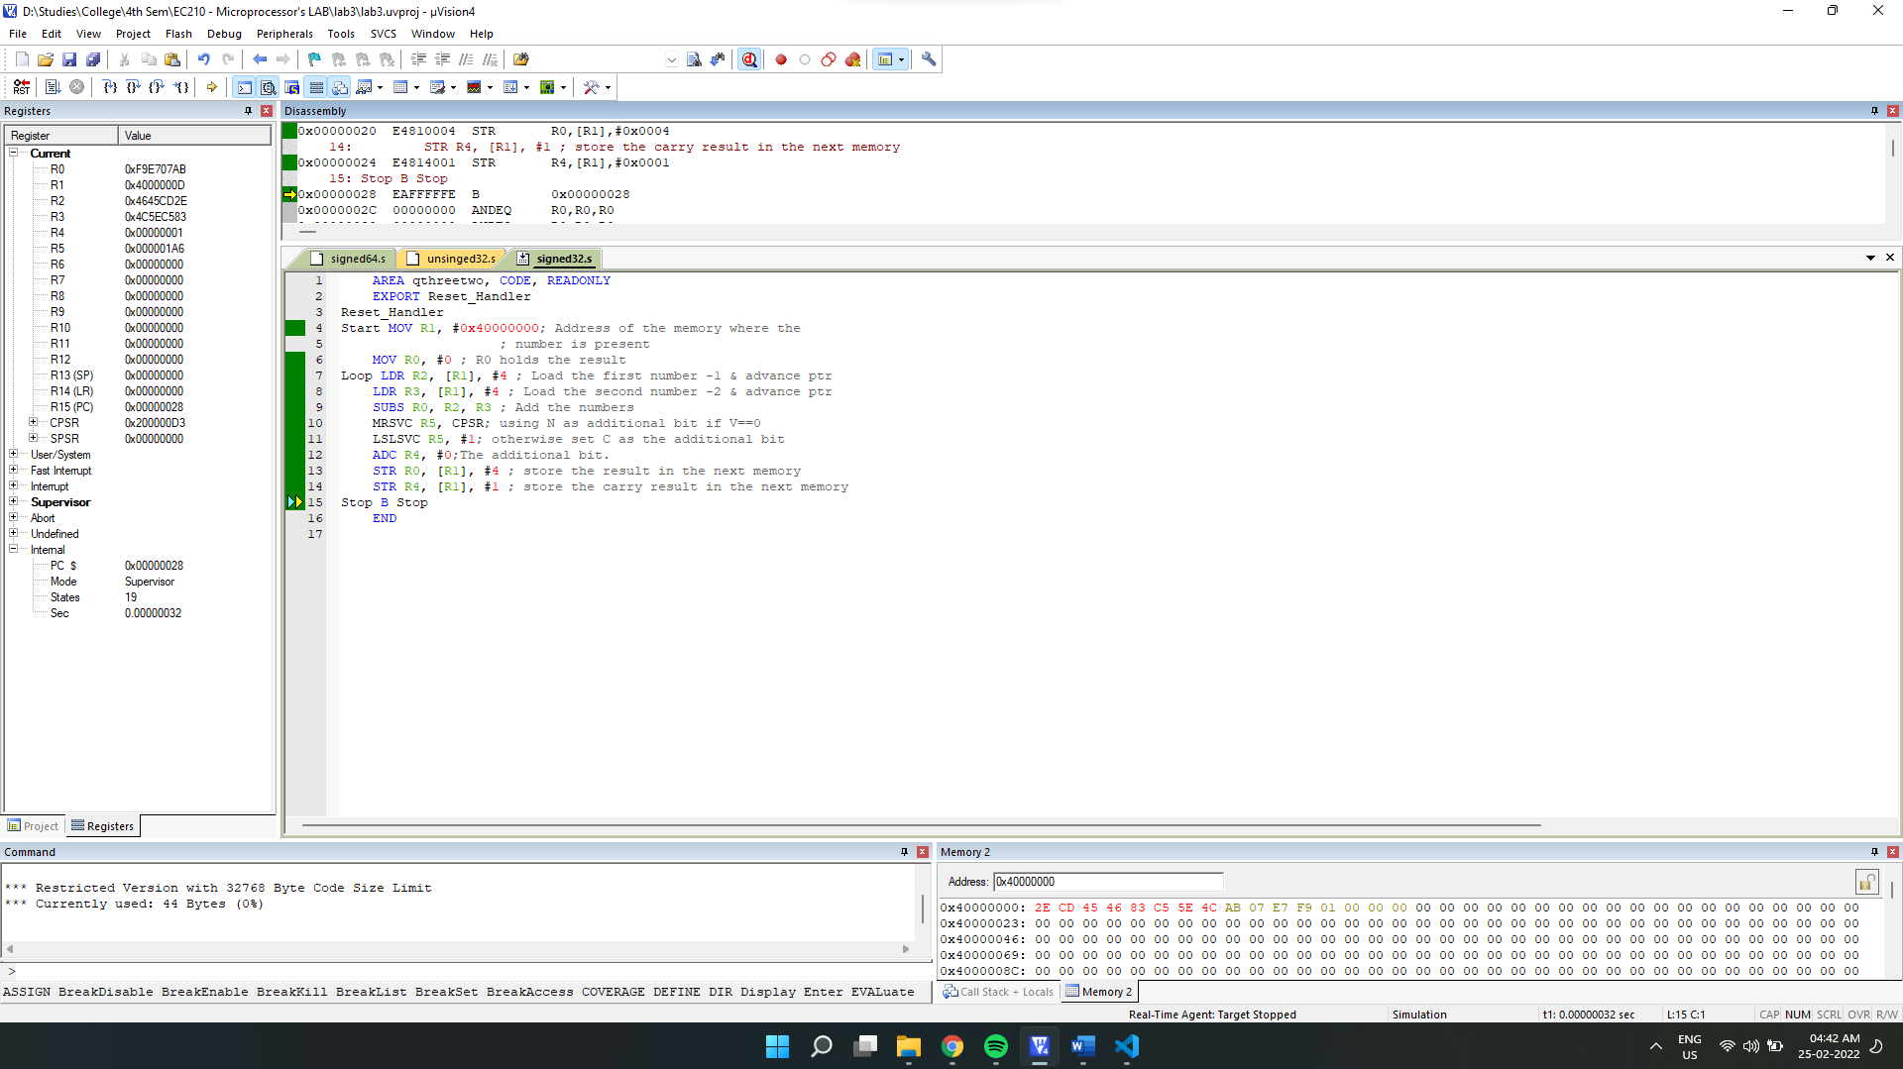

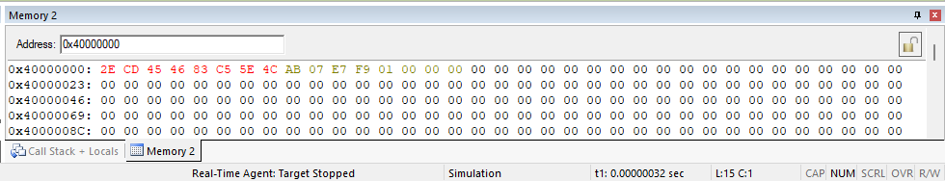

Final Register Values:

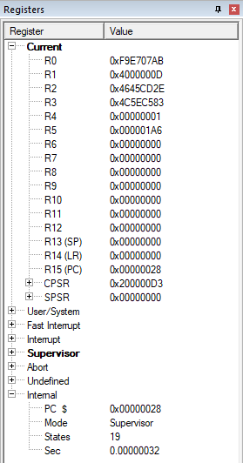

**(c) a and b are both unsigned 64 bit numbers**

We will take values from the memory and store it in R2 and R3. While calculating subtraction of signed numbers, we know that we need to consider N(Negative) as the additional bit if overflow V=0 otherwise C(carry) for the **additional** bit. We will handle this by appending **conditional execution** code **VC**. Then store the Calculated result in R6, R7 and R8. This result is later **stored in memory** locations positioned after the input value memory locations. **65th bit will be sign**

Source code:

    AREA qthreetwo, CODE, READONLY

    EXPORT Reset_Handler

Reset_Handler

Start MOV R1, #0x40000000*; Address of the memory where the*

*; number is present*

    MOV R6, #0 *; R6 and R7, R8 to hold  the result*

    MOV R7, #0 *;*

    MOV R8, #0 *;*

Loop LDR R2, [R1], #4 *; Load the first number's low & advance ptr*

    LDR R3, [R1], #4 *; Load the first number's high & advance ptr*

    LDR R4, [R1], #4 *; Load the second number's low & advance ptr*

    LDR R5, [R1], #4 *; Load the second number's high & advance ptr*

    SUBS R6, R4, R2 *; Add the numbers low*

    SBCS R7, R5, R3 *; Adding high of both numbers with carry from low add.*

    MRSVC R9, CPSR*; using N as additional bit if V==0*

    LSLSVC R9, #1*; otherwise set C as the additional bit*

    ADC R8, #0*;*

    STR R6, [R1], #4 *; store the Low result in the next memory*

    STR R7, [R1], #4 *; store the High result in the next memory*

    STR R8, [R1], #4 *; storing the carry in the next memory*

*; We have stored the 65 bits result in memory of 96bits(64 +32)*

Stop B Stop

    END

Debugging:

Initial Memory:

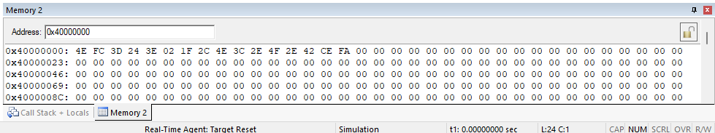

Setup:

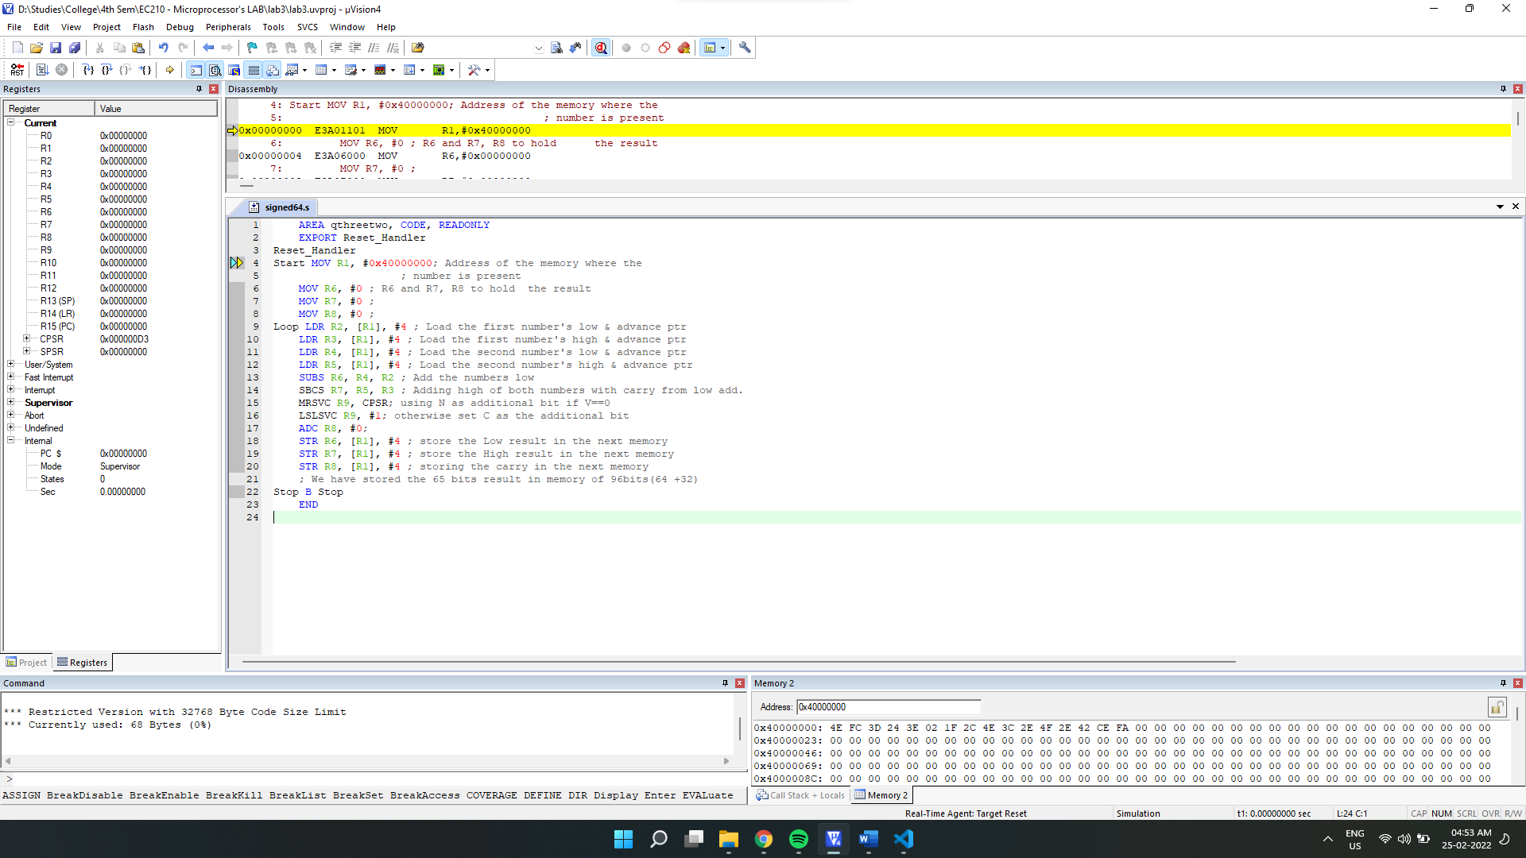

After Execution:

Final Output:

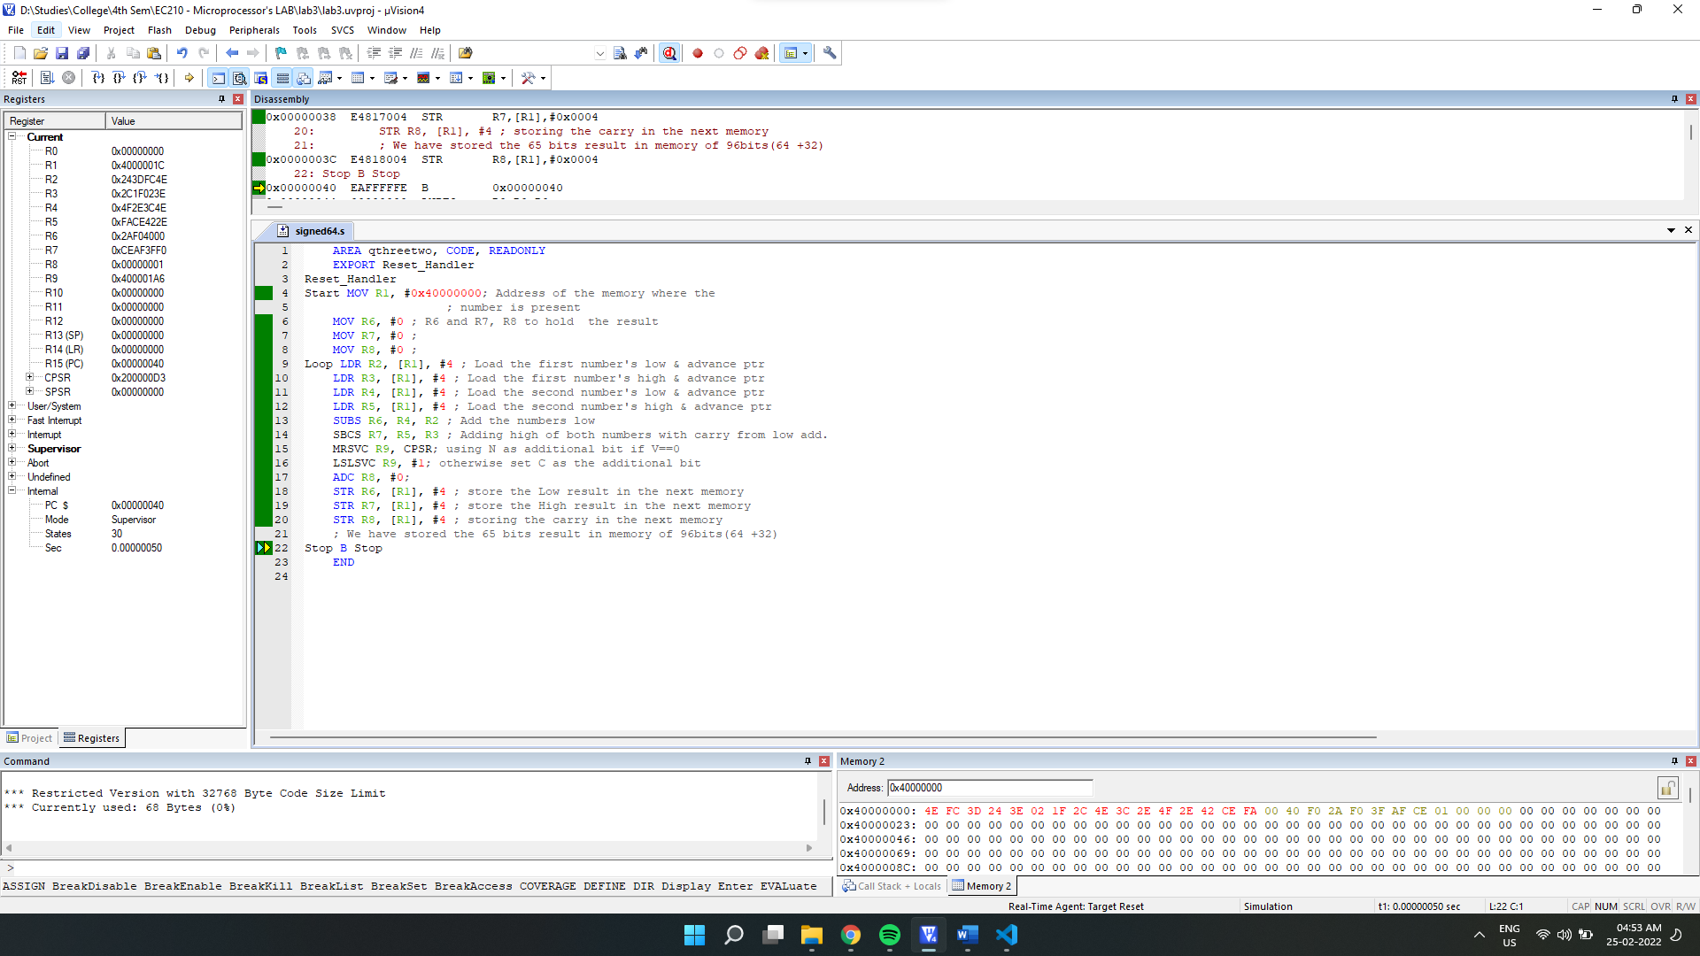

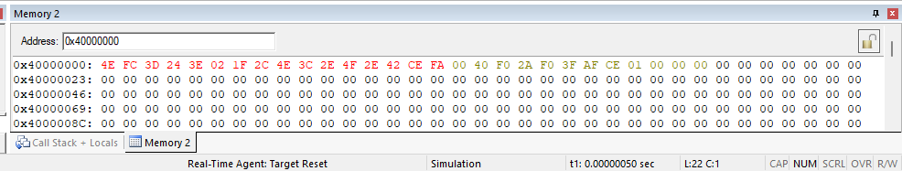

Final Register Values:

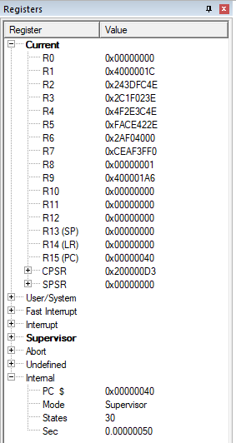

**3.4] If a and b are two 32 bit numbers stored in consecutive memory location, swap the register content using EOR instruction and store back the results.**

The EOR does bitwise XOR, this can be used to swap two variables. The XOR of two numbers x and y returns a number that has all the bits as 1 wherever bits of x and y differ.

Source code:

    AREA hmm, CODE, READONLY

    EXPORT Reset_Handler

Reset_Handler

Start MOV R1, #0x40000000*; Address of the memory where the*

*; values are present*

    MOV R3, #0 *; R3 and R4, R6 to hold  the result*

    MOV R4, #0 *;*

    LDR R3, [R1]*; Load the value_1 in R3 & advance ptr*

    LDR R4, [R1, #4]*; Load the value_2 in R4& advance ptr*

    EOR R3, R3, R4*; R3 = R3 ^ R4*

    EOR R4, R3, R4*; R4 = R3 ^ R4*

    EOR R3, R3, R4*;  R3 = R3 ^ R4*

    STR R3, [R1]*; storing the results back;*

    STR R4, [R1, #4]*;*

Stop B Stop

    END

Debugging:

Initial Memory:

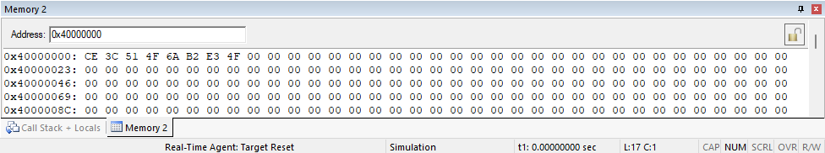Setup:

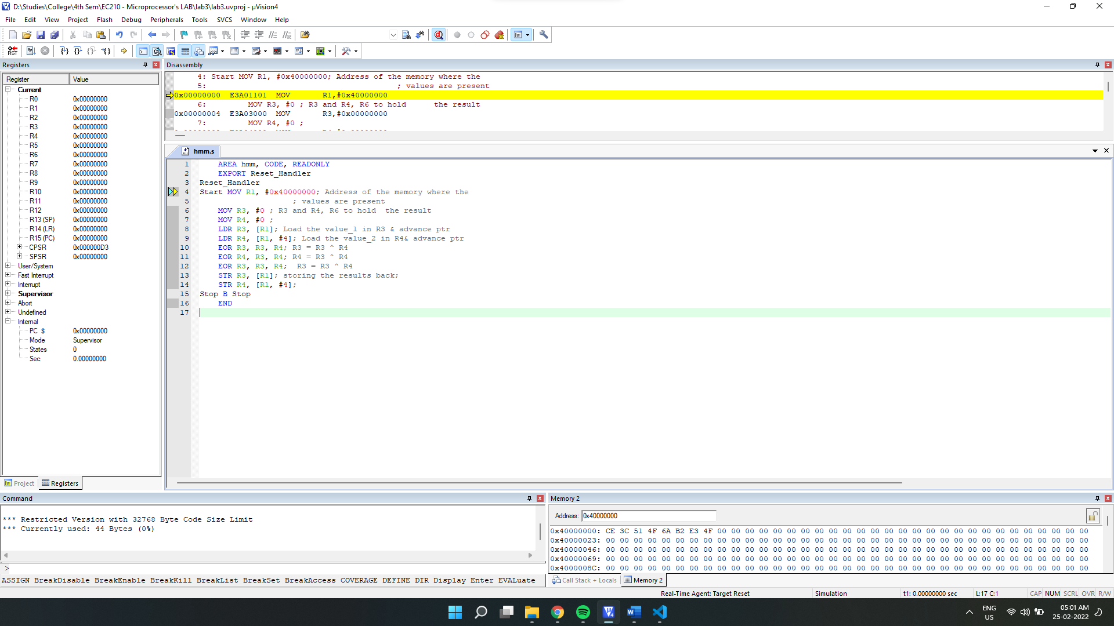

After Execution:

Final Output:

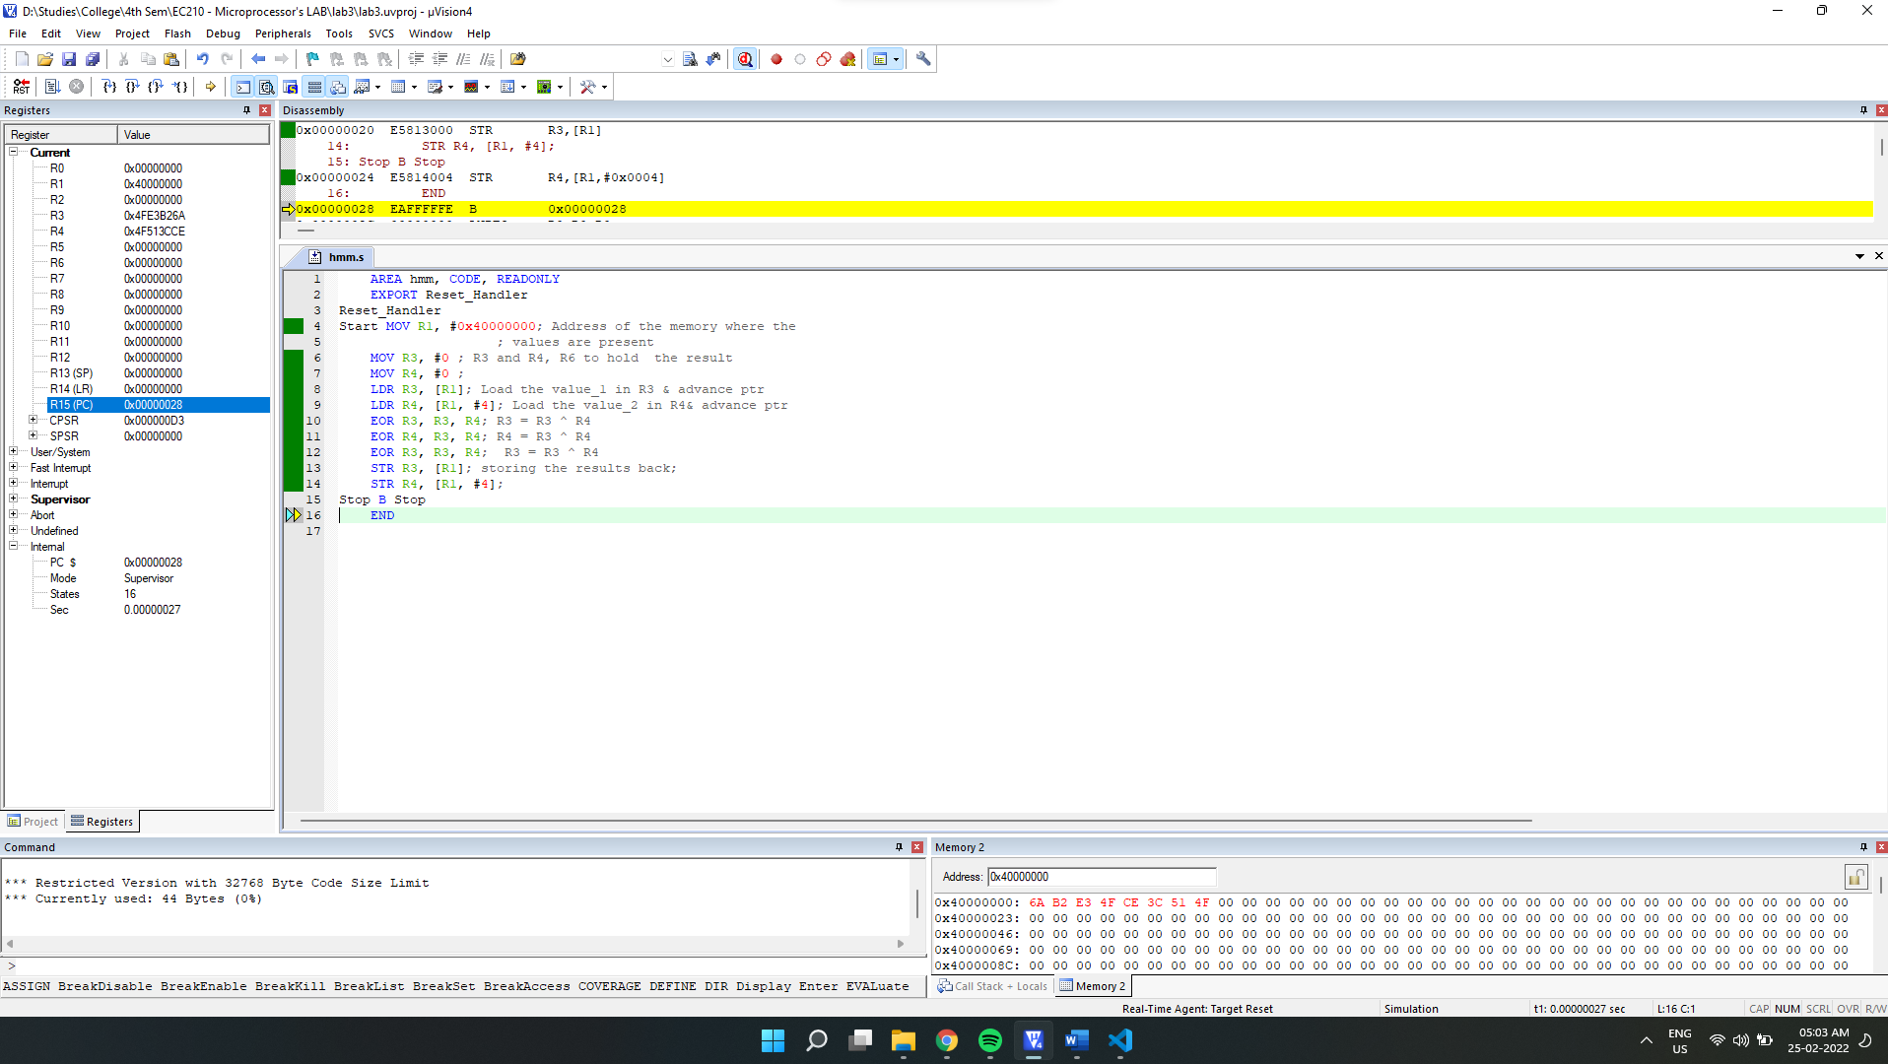

Final Memory:

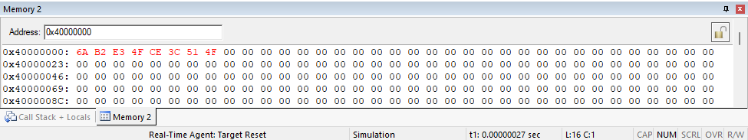

Observation: we can see that the memory values are swapped for addresses 0x40000000 and 0x40000004.

**3.5] SWP to add a constant value 0xFF to a block of 10 words stored in the consecutive memory locations using LDM and STM instructions.**

**->**

We will make use of LDMIA to load multiple registers and then use ADD instruction to add the required constant 0xFF. Then store all those values with STMIA.

Source code:

    AREA hue, CODE, READONLY

    EXPORT Reset_Handler

Reset_Handler

Start MOV R0, #0x40000000*; Address of the memory where the*

*; values is present*

    LDMIA R0, {R1-R10}*; loading the 10 values into register*

    ADD R1, #0xFF*;*

    ADD R2, #0xFF*;*

    ADD R3, #0xFF*;*

    ADD R4, #0xFF*;*

    ADD R5, #0xFF*;*

    ADD R6, #0xFF*;*

    ADD R7, #0xFF*;*

    ADD R8, #0xFF*;*

    ADD R9, #0xFF*;*

    ADD R10, #0xFF*;*

    STMIA R0, {R1-R10}*; Storing all the values into memory;*

Stop B Stop

    END

Debugging:

Initial Memory:

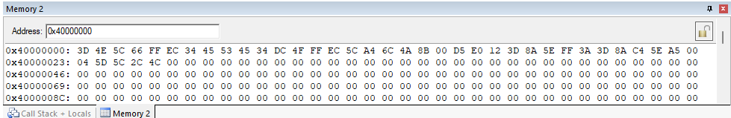

Setup:

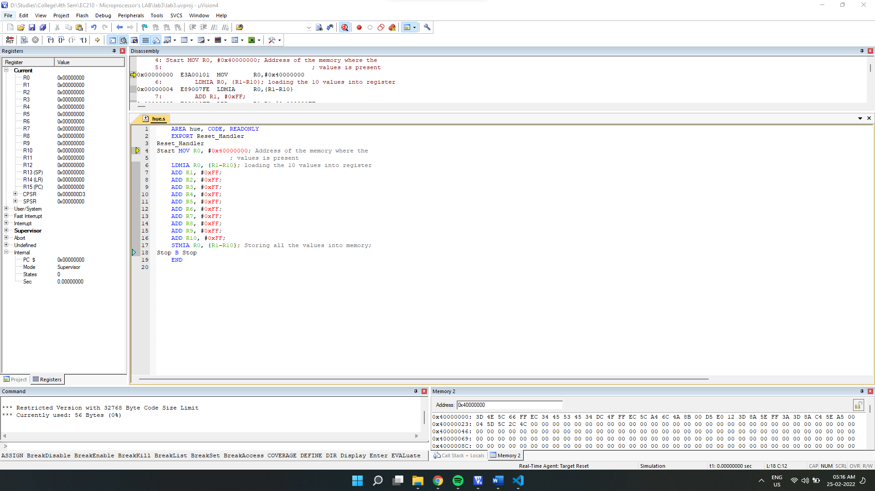

After Registers get loaded:

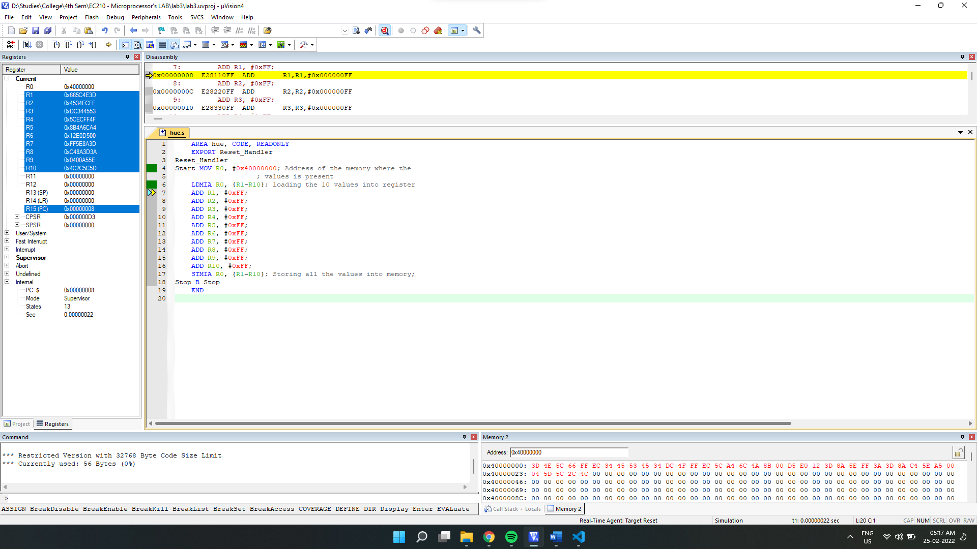

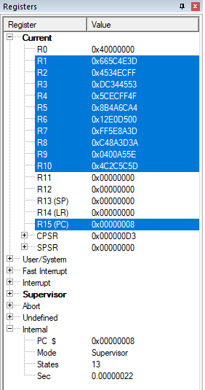

After complete Execution:

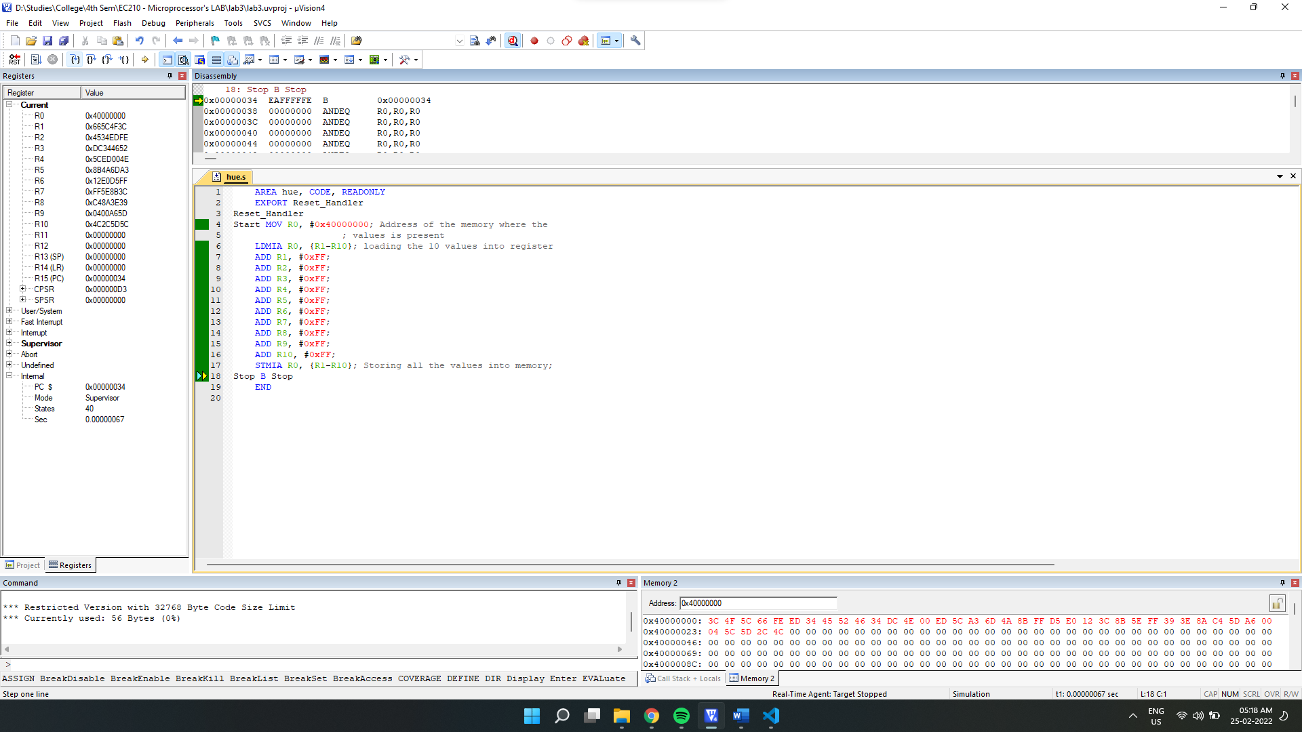

Final Output:

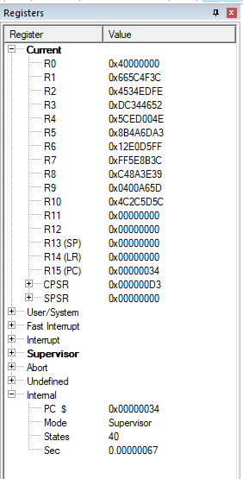

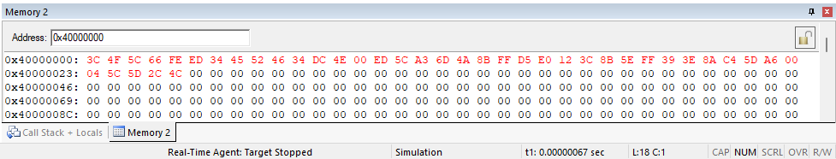

**3.6] Exchange a block of 32 bit data stored in the processor registers (R0- R7) with that in the memory starting at address 0x40000000.**

We will first load values into registers r0-r7 (from different memory location 0x50000000) that are to be swapped from the memory at location starting from **0x40000000** using LDMIA. Then we will make use of **SWP** instruction to swap values between register and memory. For repeating the instruction for different registers, we will use **ADD** instruction to increment the register storing the address.

Source code:

    AREA huihui, CODE, READONLY

    EXPORT Reset_Handler

Reset_Handler

Start MOV R9, #0x50000000*; for loading values into register*

    LDMIA R9, {R0-R7}*; Loading values into register that are to be swapped.*

    MOV R8, #0x40000000*; Address of the memory of which*

*; The values are to be swapped with the registers.*

    SWP R0, R0, [R8]*;*

    ADD R8, #4*;*

    SWP R1, R1, [R8]*;*

    ADD R8, #4*;*

    SWP R2, R2, [R8]*;*

    ADD R8, #4*;*

    SWP R3, R3, [R8]*;*

    ADD R8, #4*;*

    SWP R4, R4, [R8]*;*

    ADD R8, #4*;*

    SWP R5, R5, [R8]*;*

    ADD R8, #4*;*

    SWP R6, R6, [R8]*;*

    ADD R8, #4*;*

    SWP R7, R7, [R8]*;*

Stop B Stop

    END

Debugging:

Initial Memory:

From 0x40000000

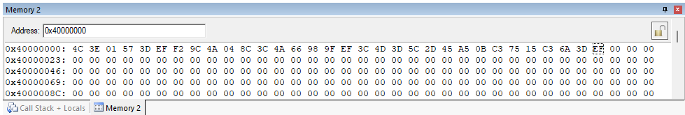

From 0x50000000 (for initializing register)

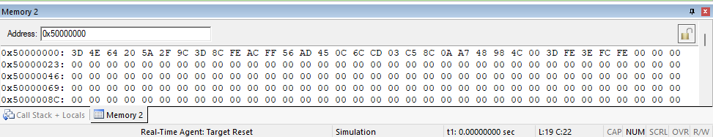

Setup:

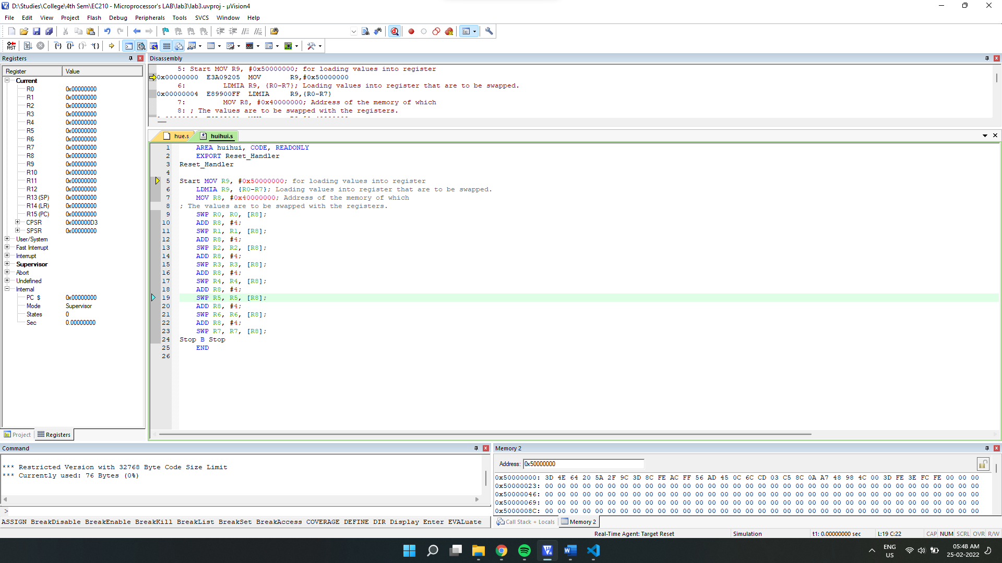

After registers get loaded:

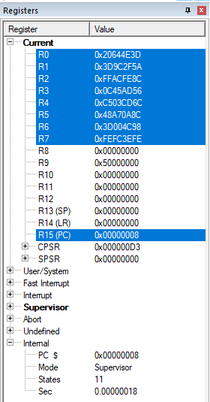

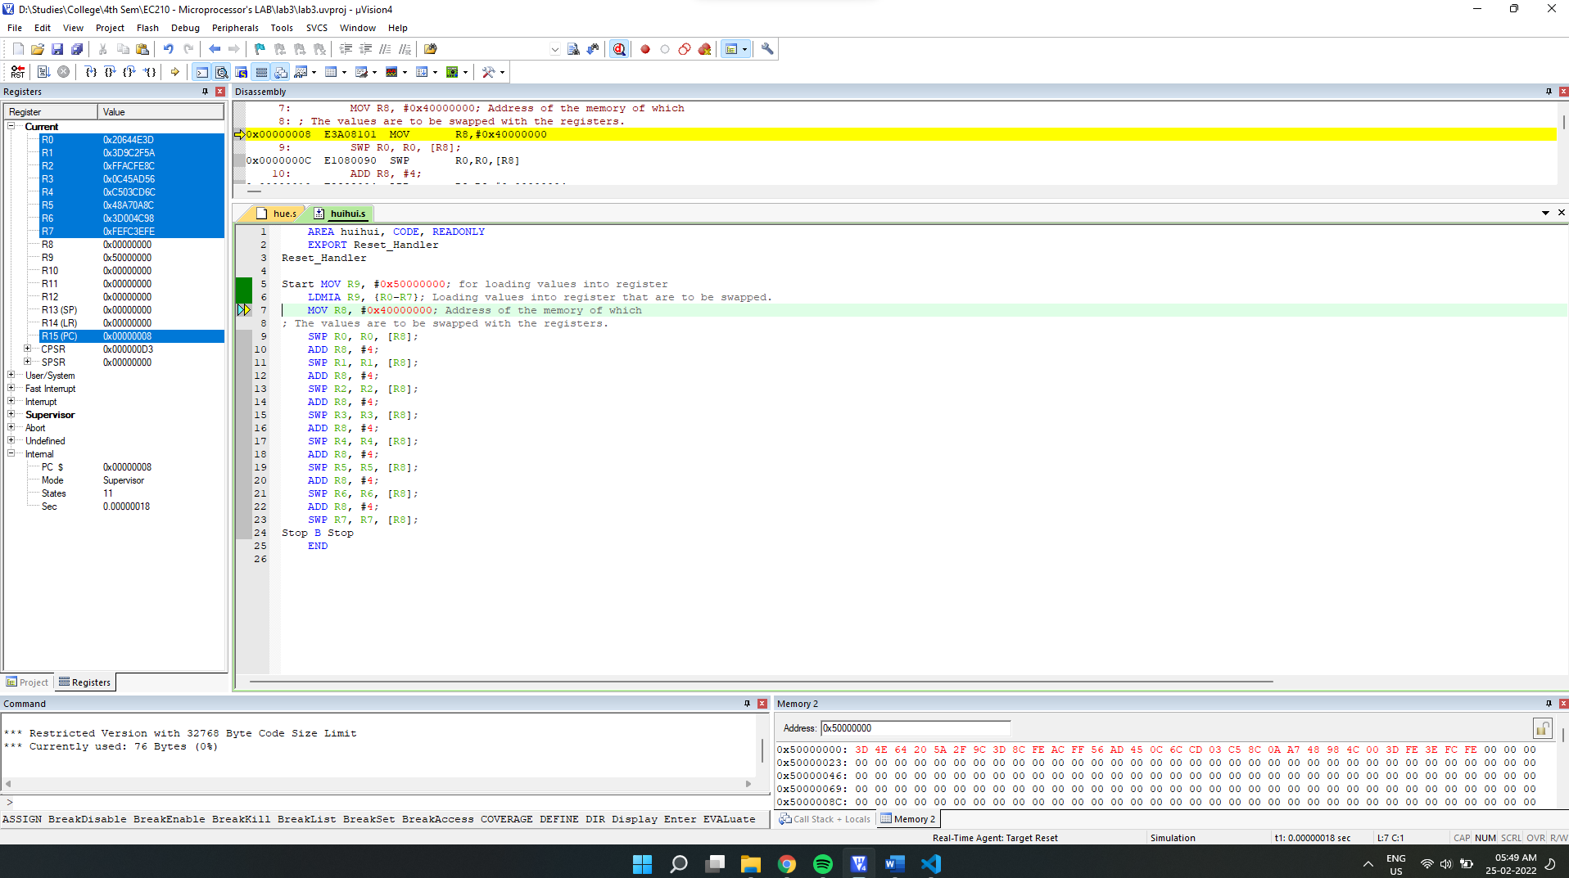

After Execution:

Final Output:

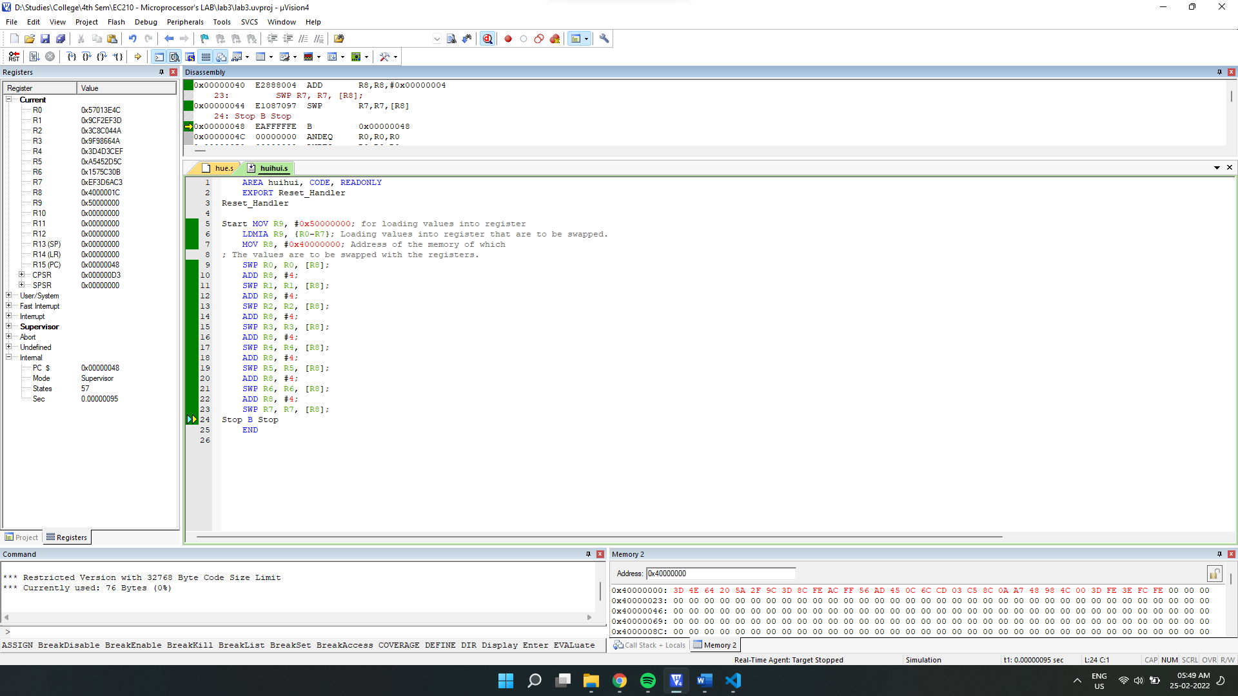

Final Values:

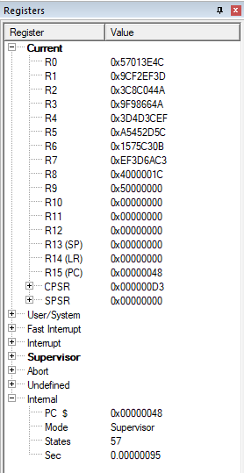

From 0x40000000

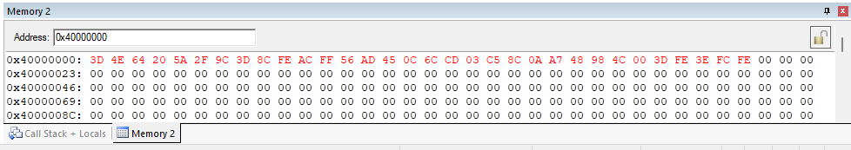

**Observation:**

We can see that values are swapped.

3.7] Take two Nos from the memory, No1 and No2 as given below No1= 0xBDF85433 and No2 =0x8FFF5FF3

No1= 0x967ff500 and No2 =0x50000000

No1 =0x74FFF000 and No2 =0x6800AFFF

No1 =0x80000000 and No2 =0xFFFF0000

(A) For each case perform 32 bit signed comparison and set the register R3 to 0xFF is No1 is greater than No2. Else set R3 to 0x00 using conditional execution of instructions.

(B) For each case perform 32 bit unsigned comparison and set the register R3 to 0xFF is No1 is greater than No2. Else set R3 to 0x00 using conditional execution of instructions.

->

**a)**  We will use LDR for first loading both the values into register, then compare them with CMP and then make use of condition execution code **GT(for signed numbers)** as suffix with **ADD** instruction made to add 0xFF in R3 for required condition(greater than).

Source Code:

    AREA qthreetwo, CODE, READONLY

    EXPORT Reset_Handler

Reset_Handler

Start MOV R1, #0x40000000*; Address of the memory where the*

*; number is present*

    MOV R3, #0 *; R3 holds the result*

    LDR R0, [R1], #4 *; Load the first number & advance ptr*

    LDR R2, [R1], #4 *; Load the second number  & advance ptr*

    CMP R0, R2*; compare*

    ADDGT R3, #0xFF*; add if greater than(signed)*

Stop B Stop

    END

**No1= 0xBDF85433 and No2 =0x8FFF5FF3**

Debugging:

Initial Memory:

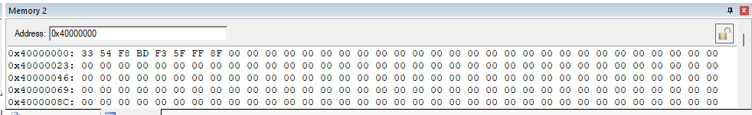

Setup:

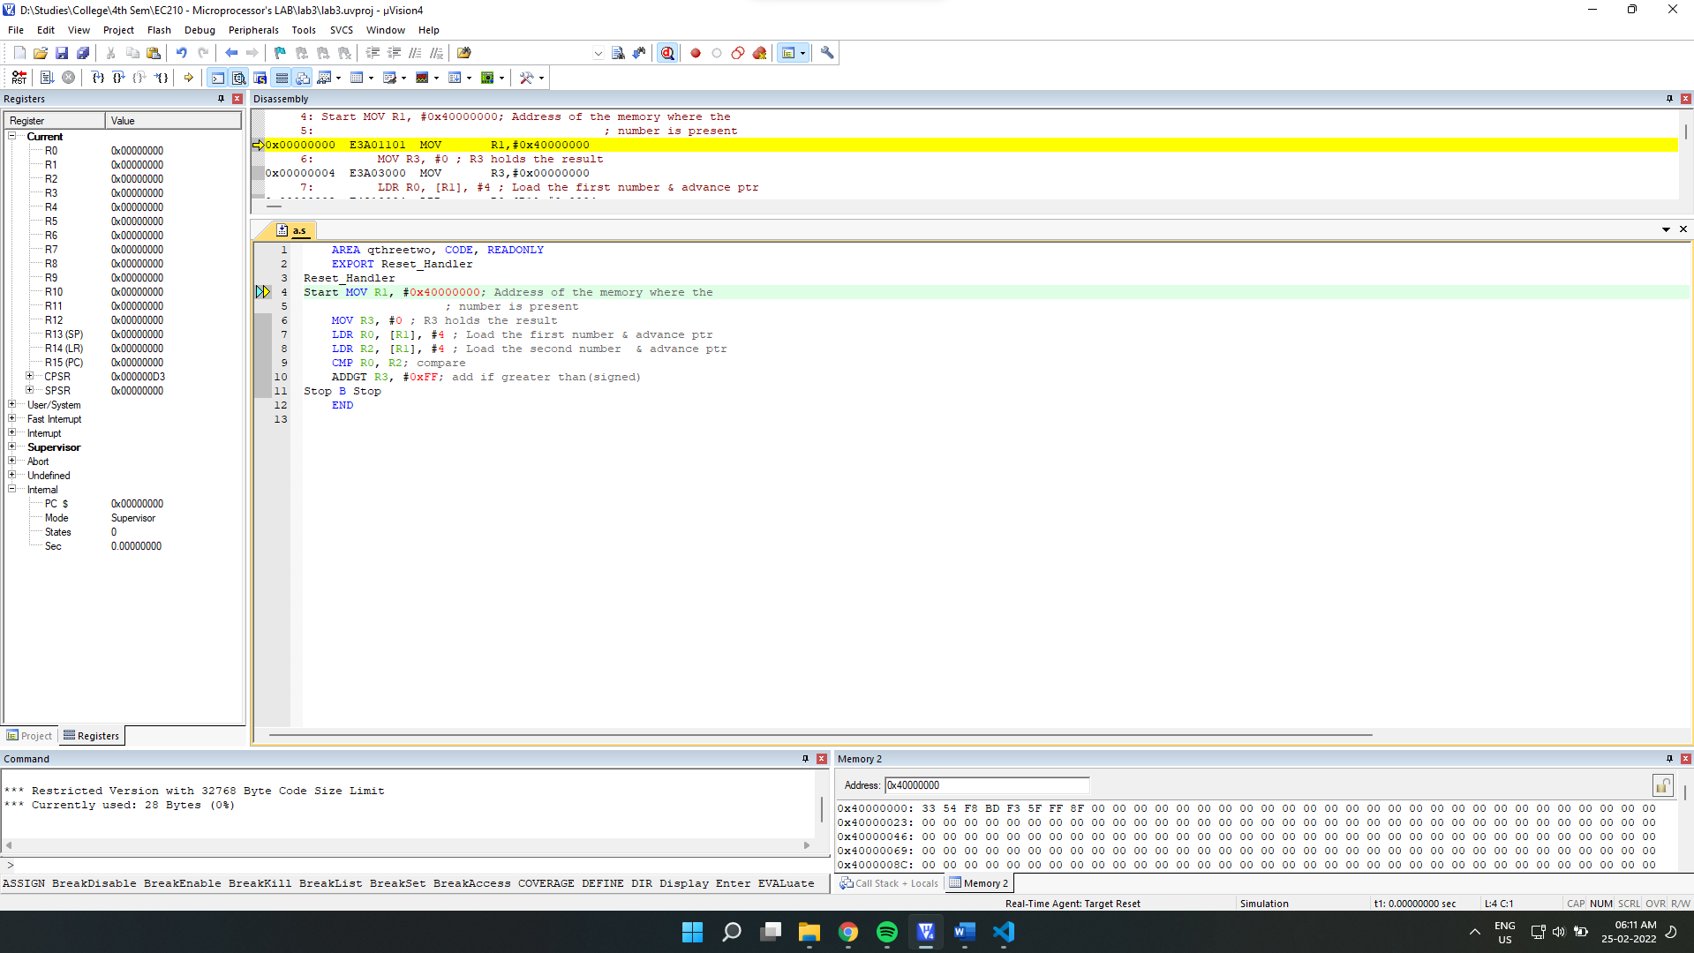

Final Output:

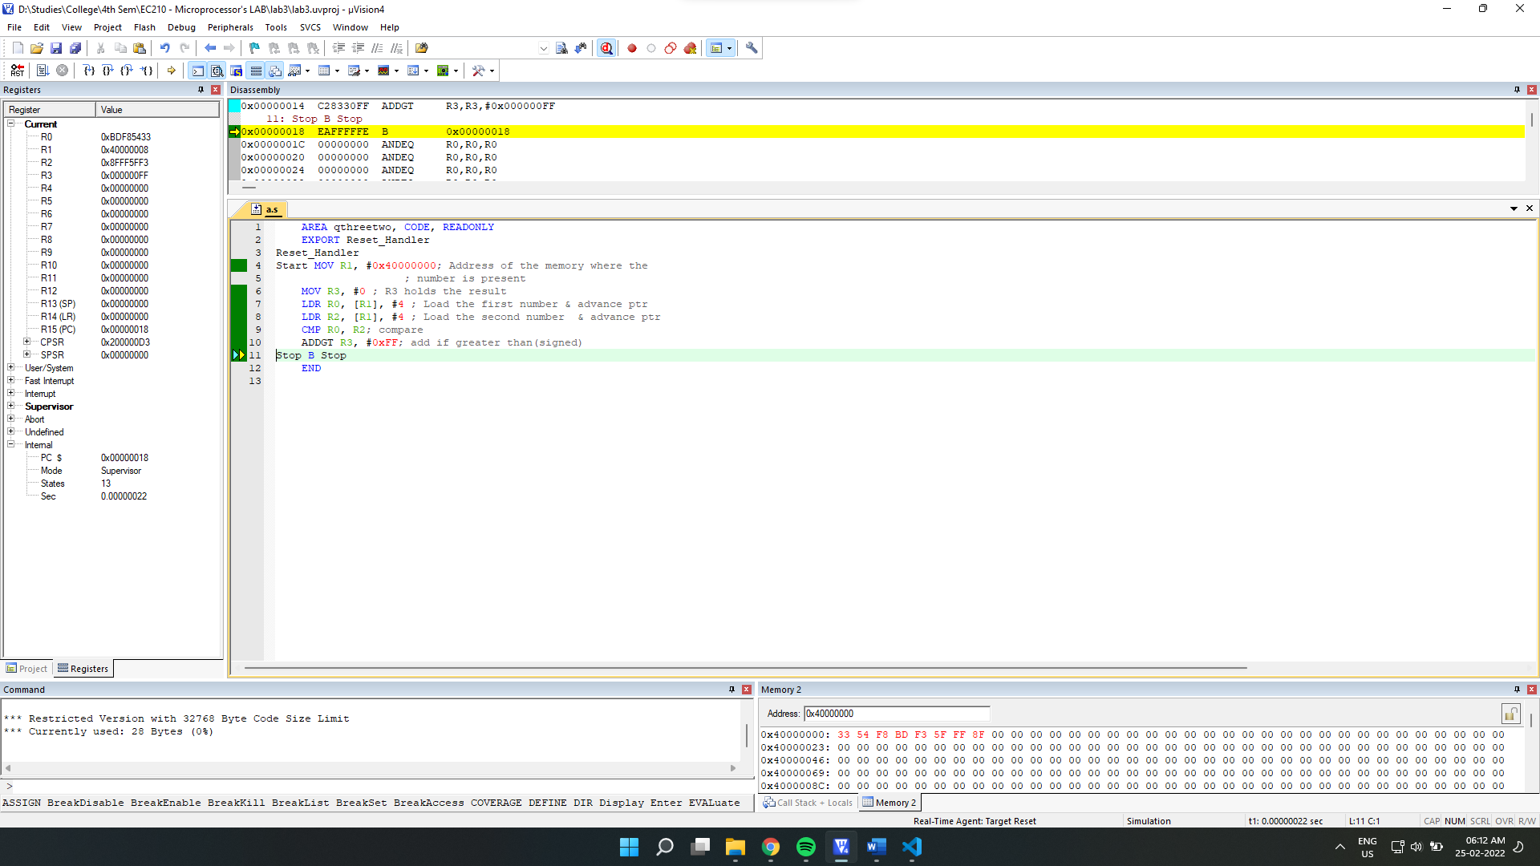

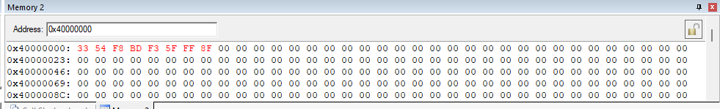

Final Register Values:

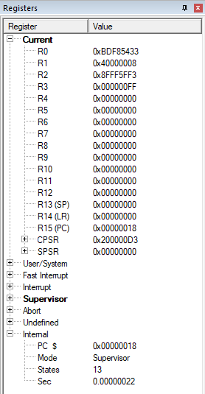

**No1= 0x967ff500 and No2 =0x50000000**

Debugging:

Initial Memory:

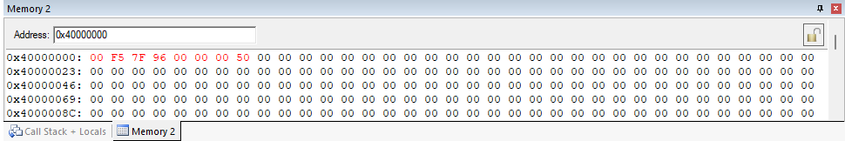

Setup:

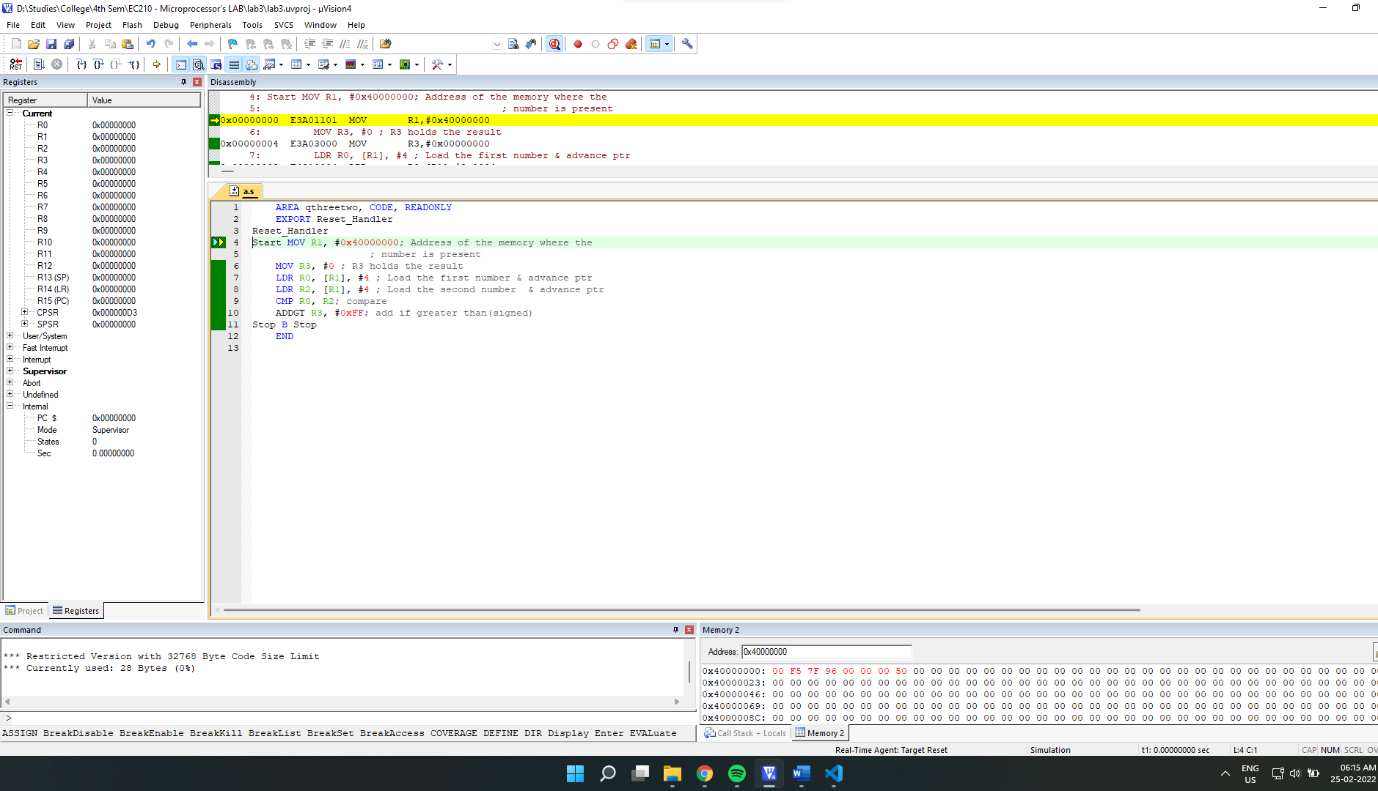

After Execution:

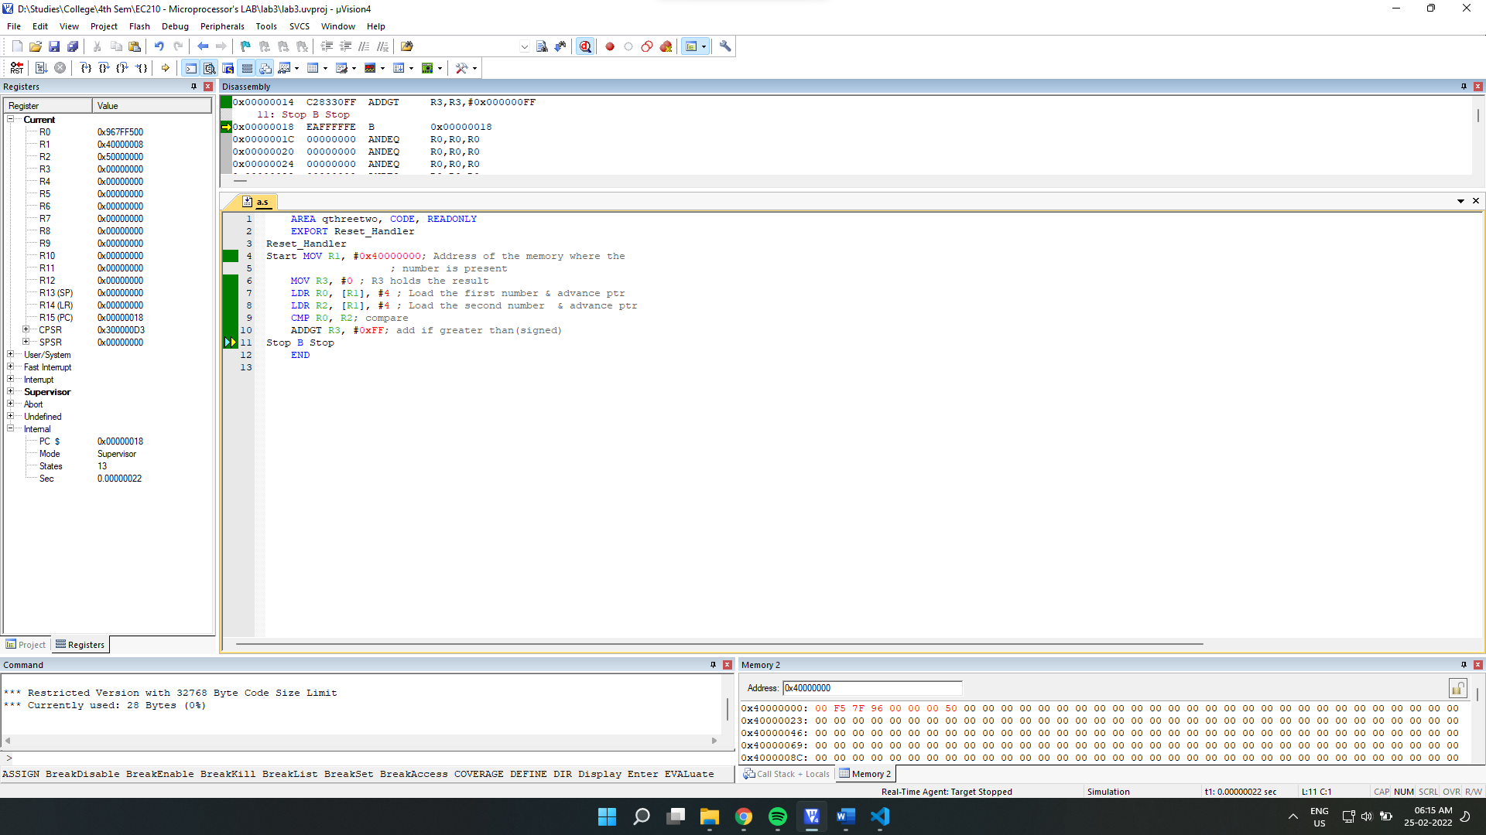

Final Output:

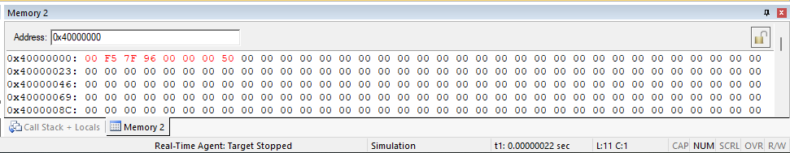

Final Register Values:

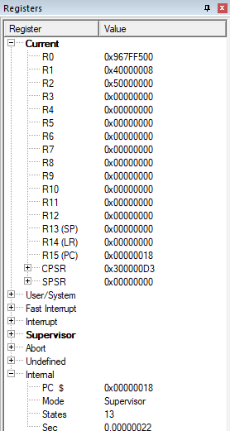

**No1 =0x74FFF000 and No2 =0x6800AFFF**

Debugging:

Initial Memory:

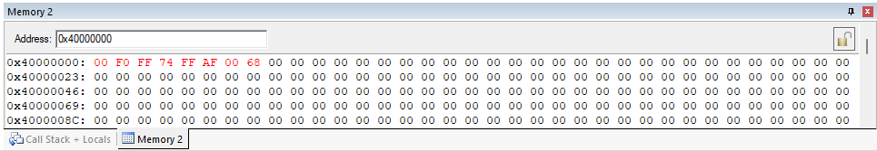

Setup:

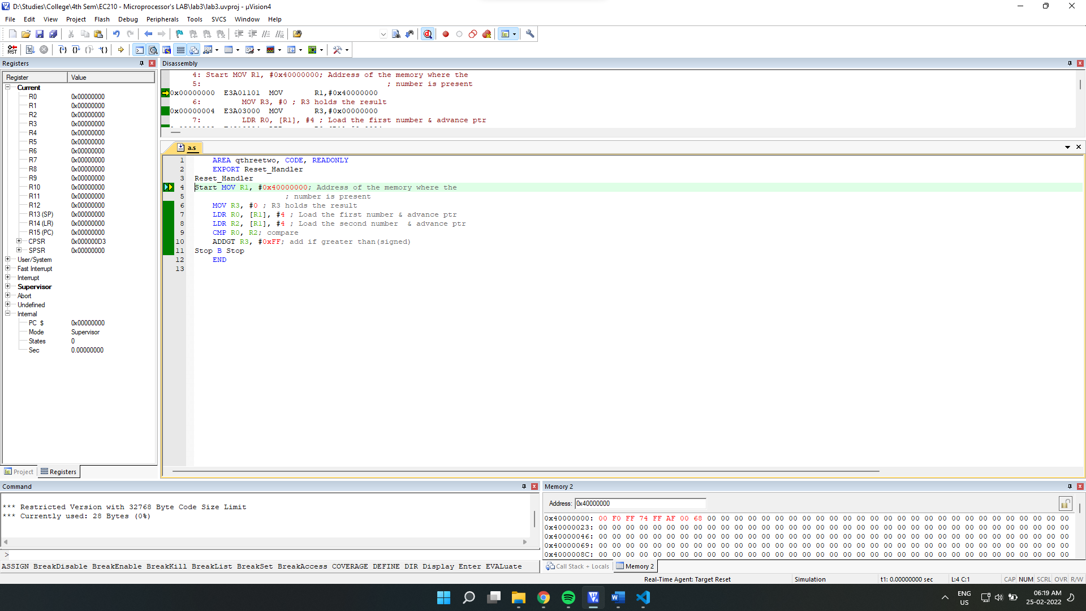

After Execution:

Final Output:

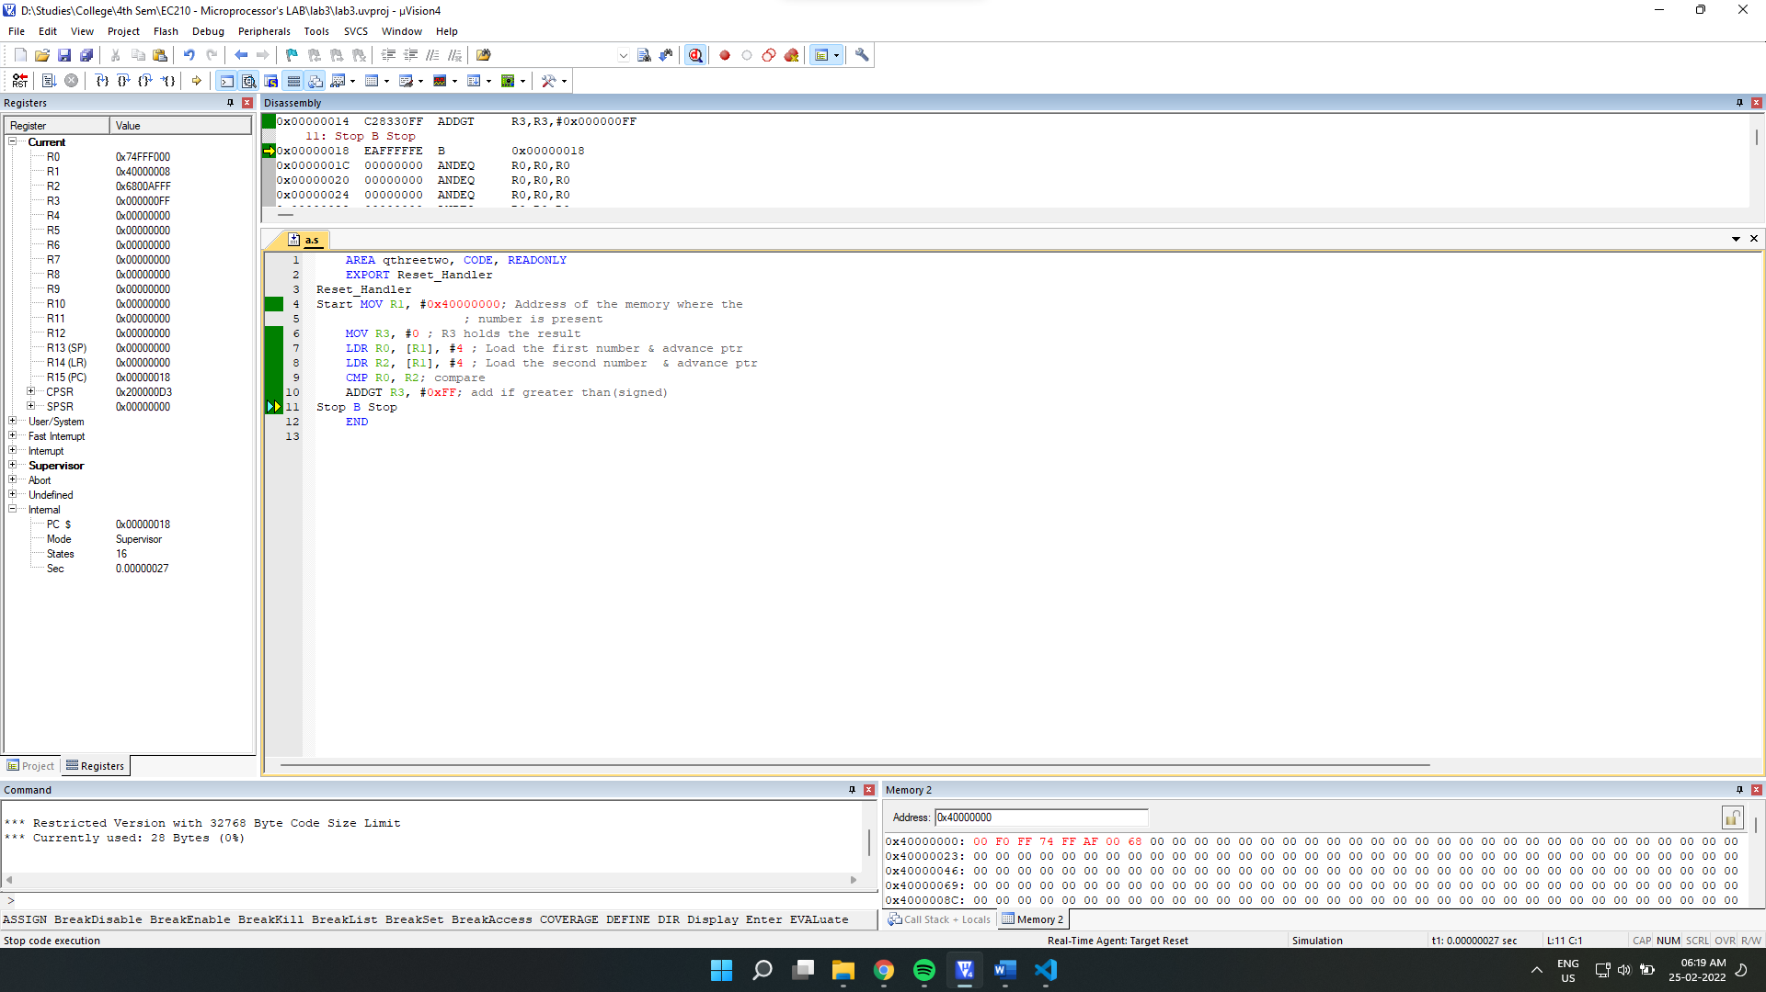

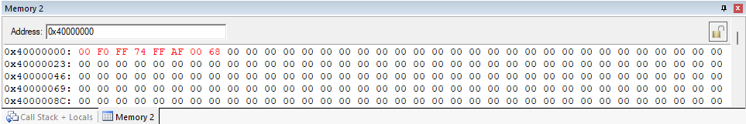

Final Register Values:

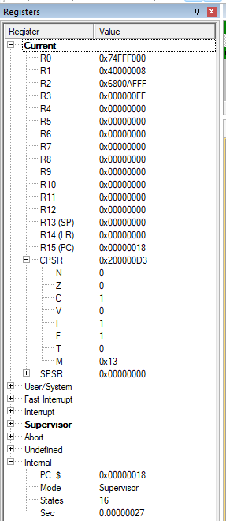

**No1 =0x80000000 and No2 =0xFFFF0000**

Debugging:

Initial Memory:

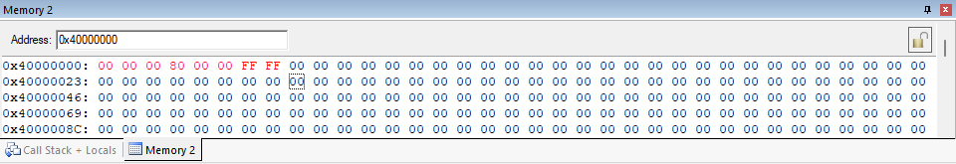

Setup:

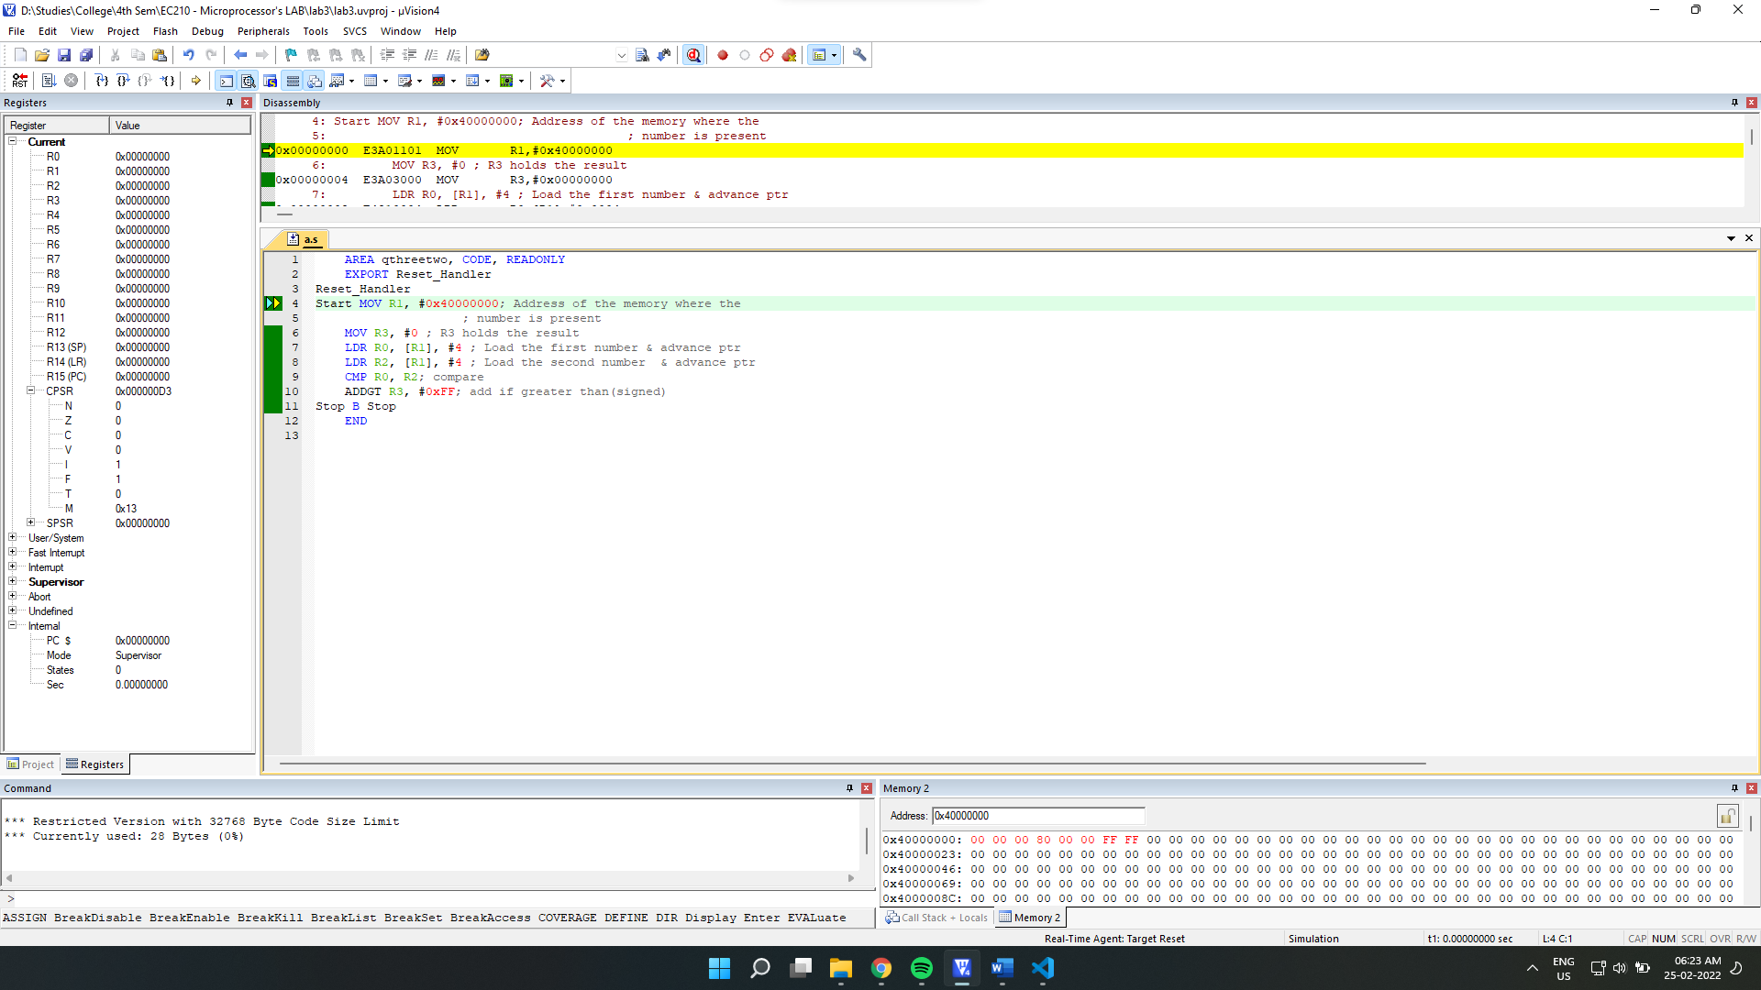

After Execution:

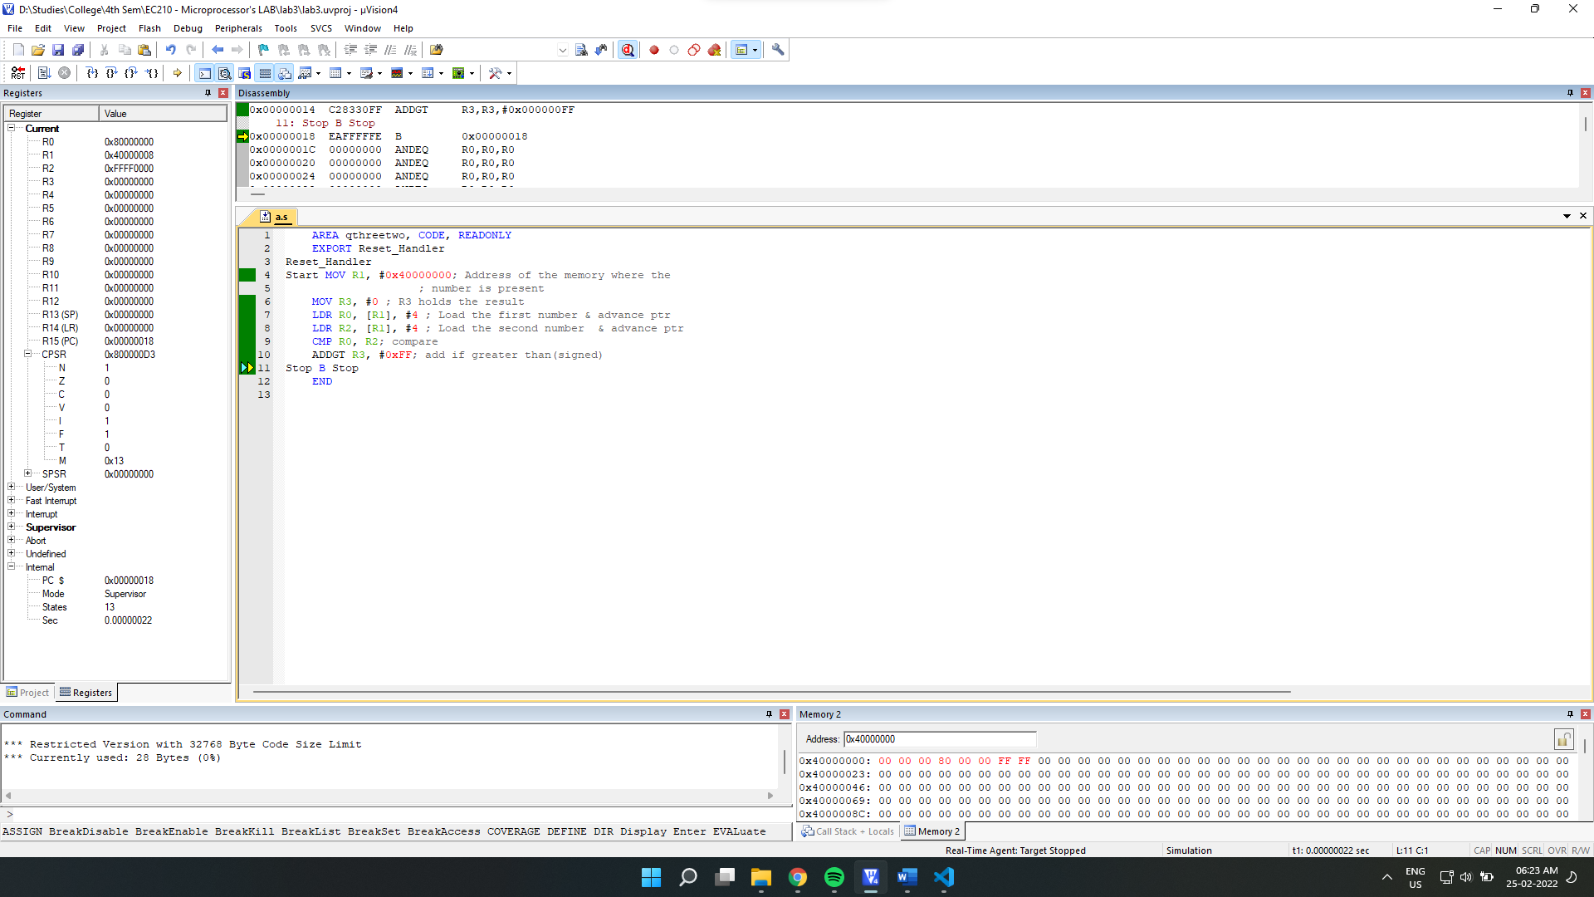

**Final Output:**

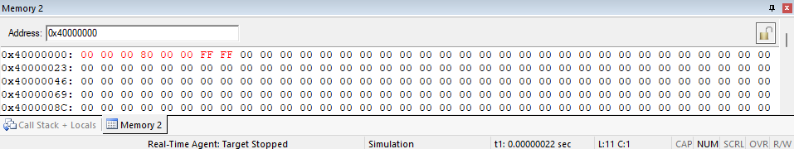

Final Register Values:

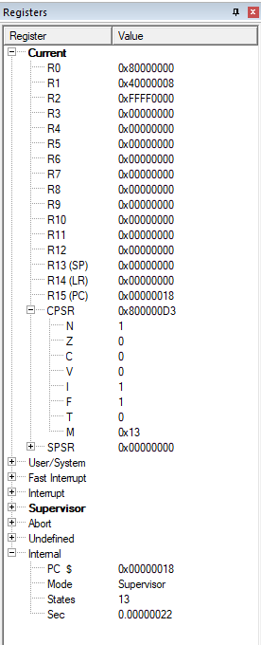

**b)** We will use LDR for first loading both the values into register, then compare them with CMP and then make use of condition execution code **HI(for unsigned numbers)** as suffix with **ADD** instruction made to add 0xFF in R3 for required condition(higher than/ greater than).

->

Source Code:

    AREA qthreetwo, CODE, READONLY

    EXPORT Reset_Handler

Reset_Handler

 Start MOV R1, #0x40000000*; Address of the memory where the*

*; number is present*

    MOV R3, #0 *; R3 holds the result*

    LDR R0, [R1], #4 *; Load the first number & advance ptr*

    LDR R2, [R1], #4 *; Load the second number & advance ptr*

    CMP R0, R2*; compare*

    ADDHI R3, #0xFF*; add if higher/greater than(unsigned)*

Stop B Stop

    END

**No1= 0xBDF85433 and No2 =0x8FFF5FF3**

Debugging:

Initial Memory:

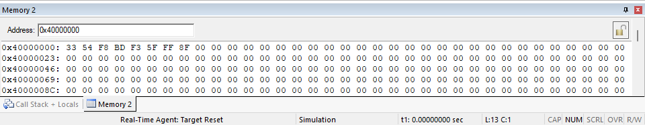

Setup:

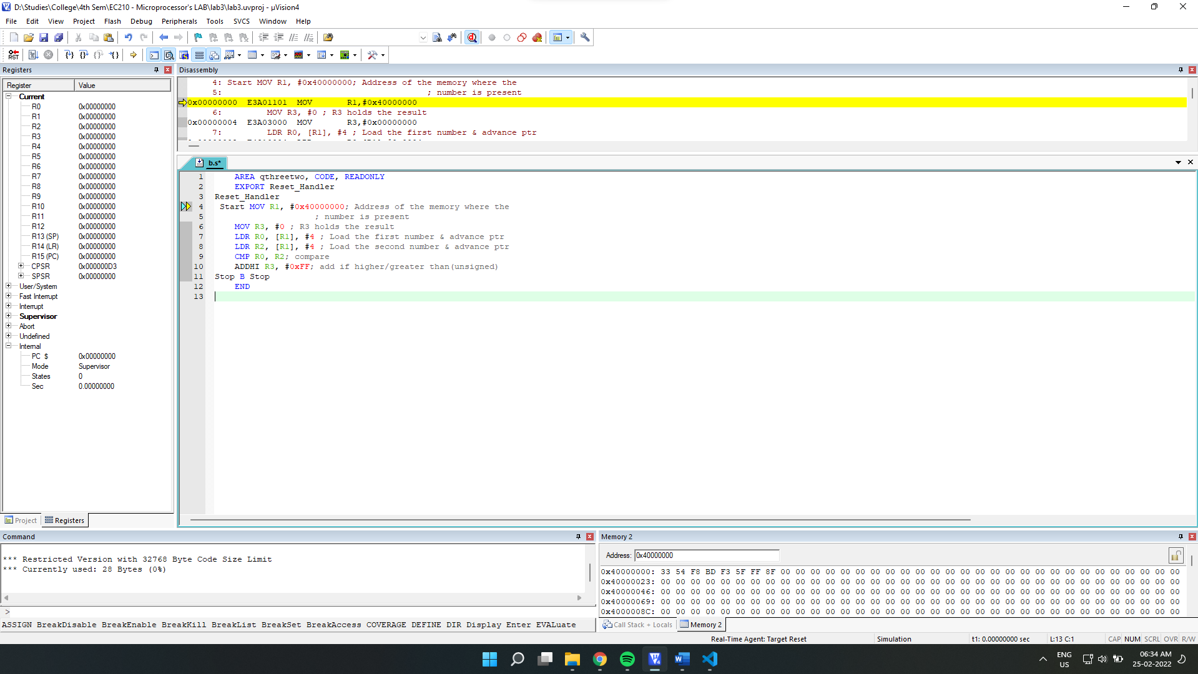

After Execution:

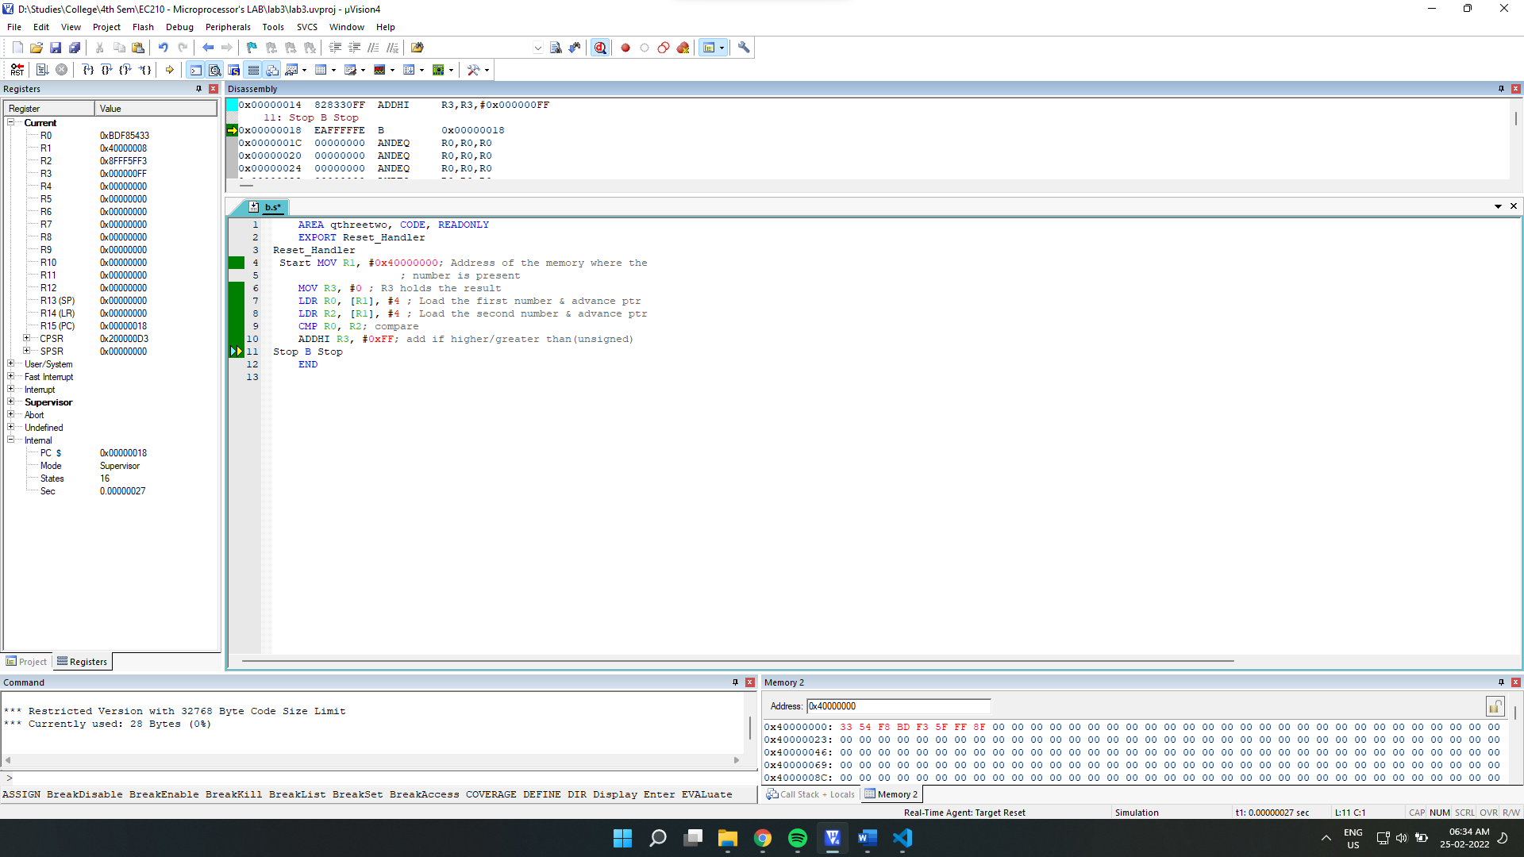

Final Output:

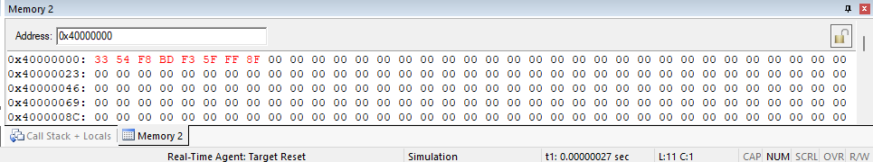

Final Register Values:

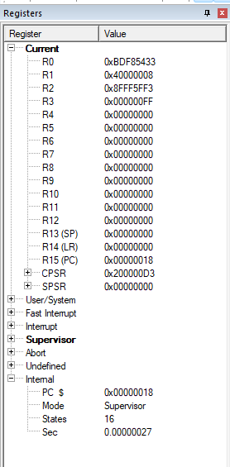

**No1= 0x967ff500 and No2 =0x50000000**

Debugging:

Initial Memory:

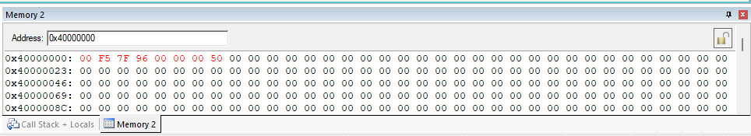

Setup:

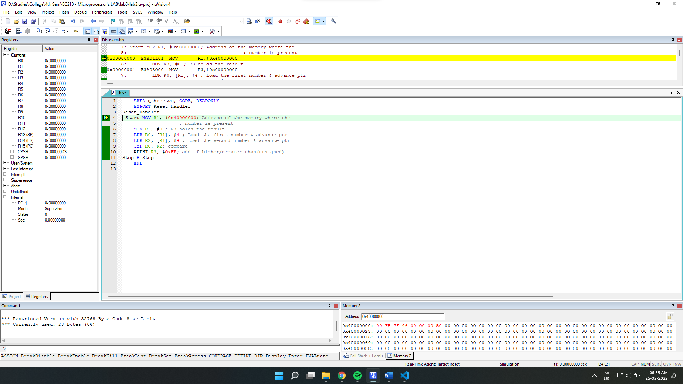

After Execution:

Final Output:

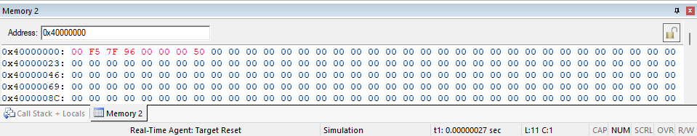

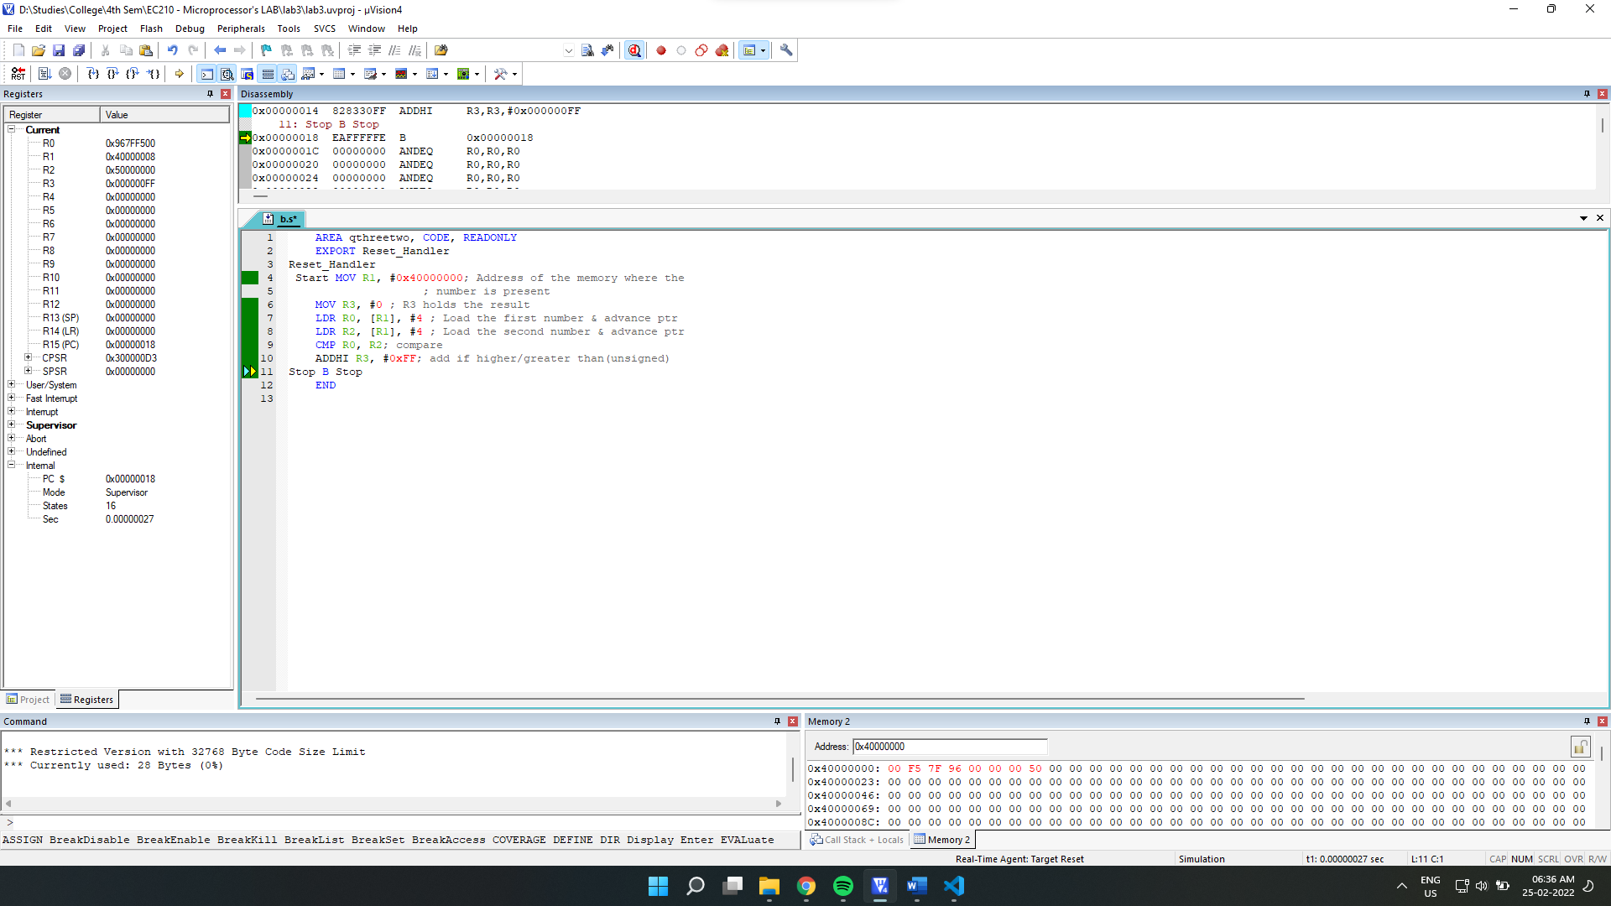

Final Register Values:

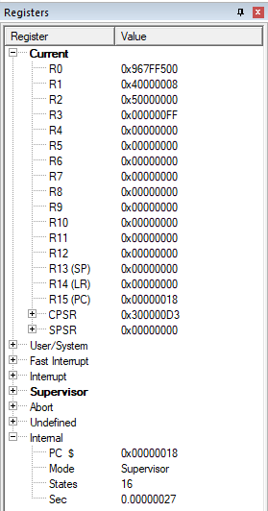

**No1 =0x74FFF000 and No2 =0x6800AFFF**

Debugging:

Initial Memory:

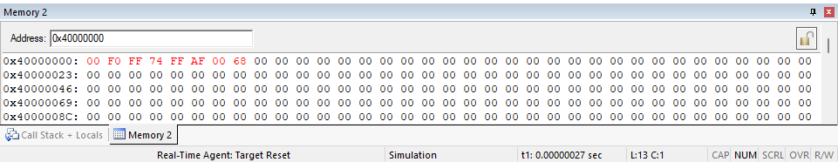

Setup:

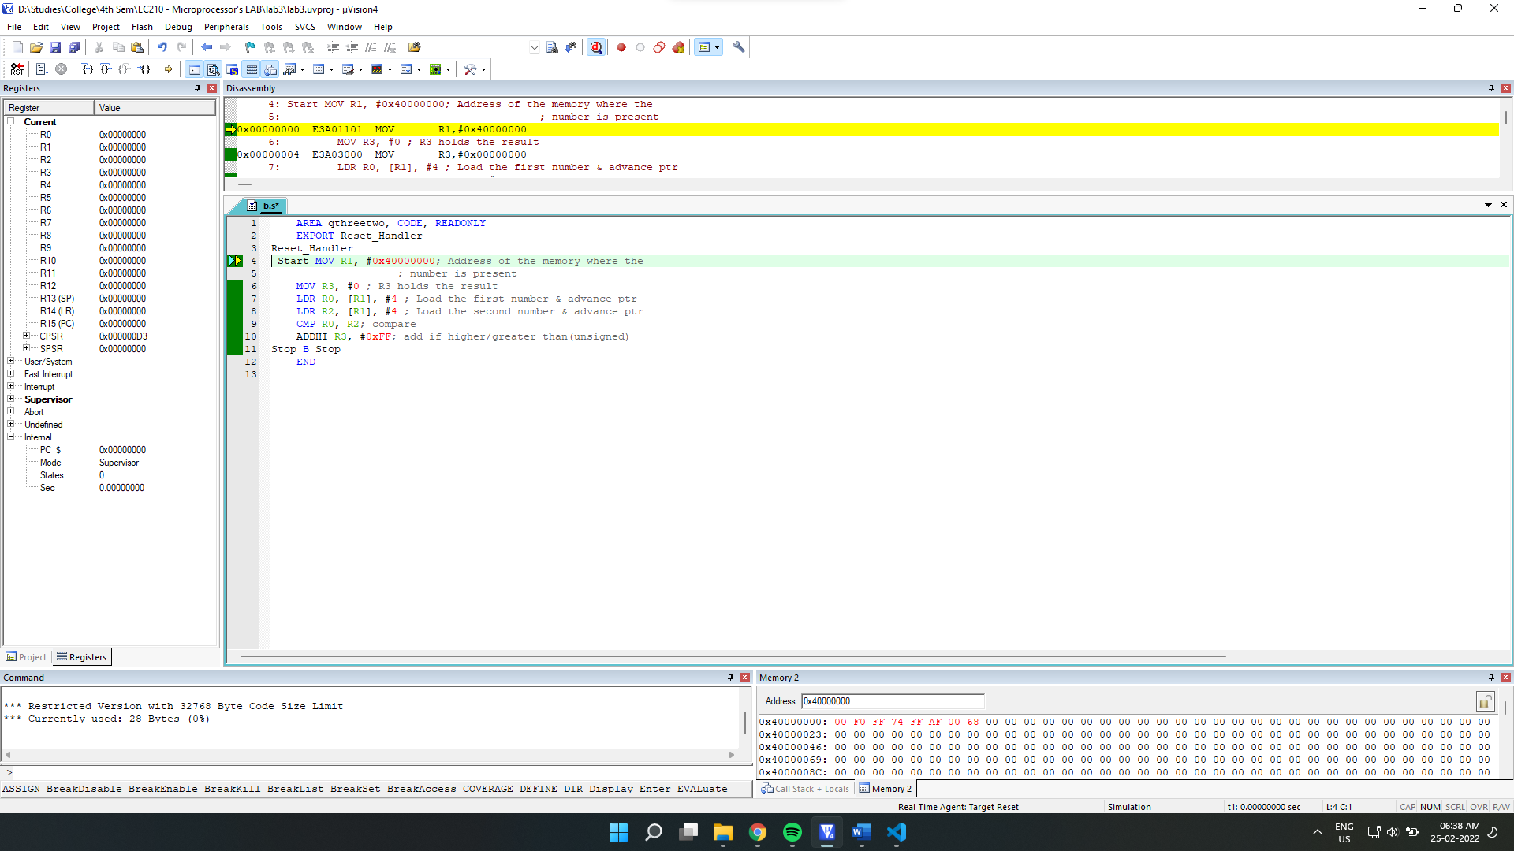

After Execution:

Final Output:

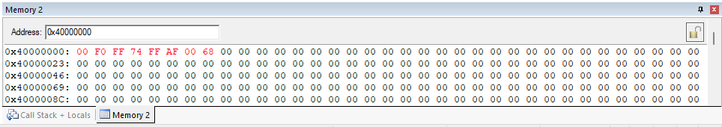

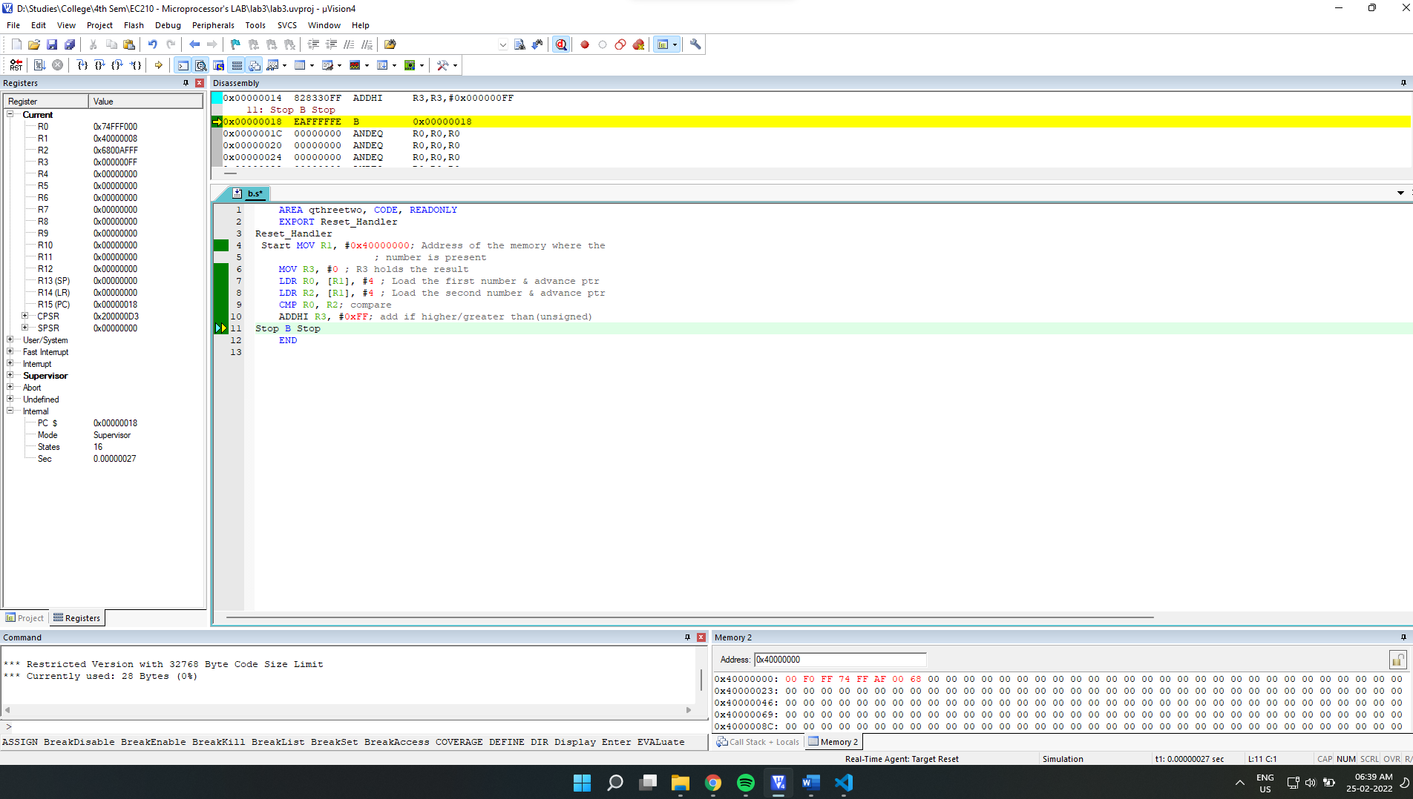

Final Register Values:

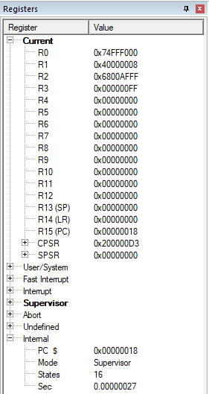

**No1 =0x80000000 and No2 =0xFFFF0000**

Debugging:

Initial Memory:

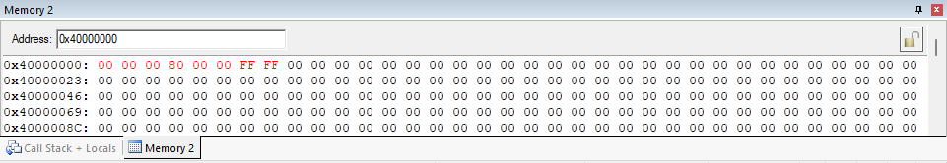

Setup:

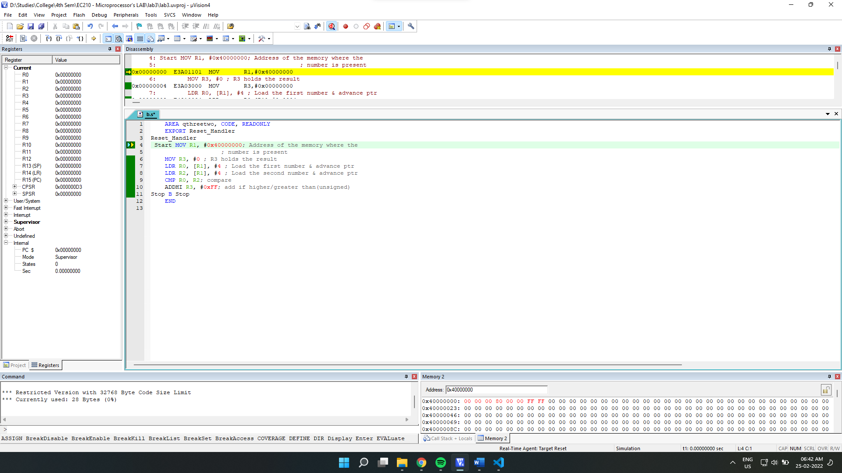

After Execution:

Final Output:

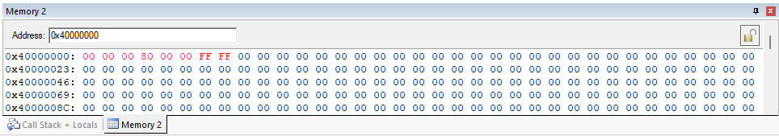

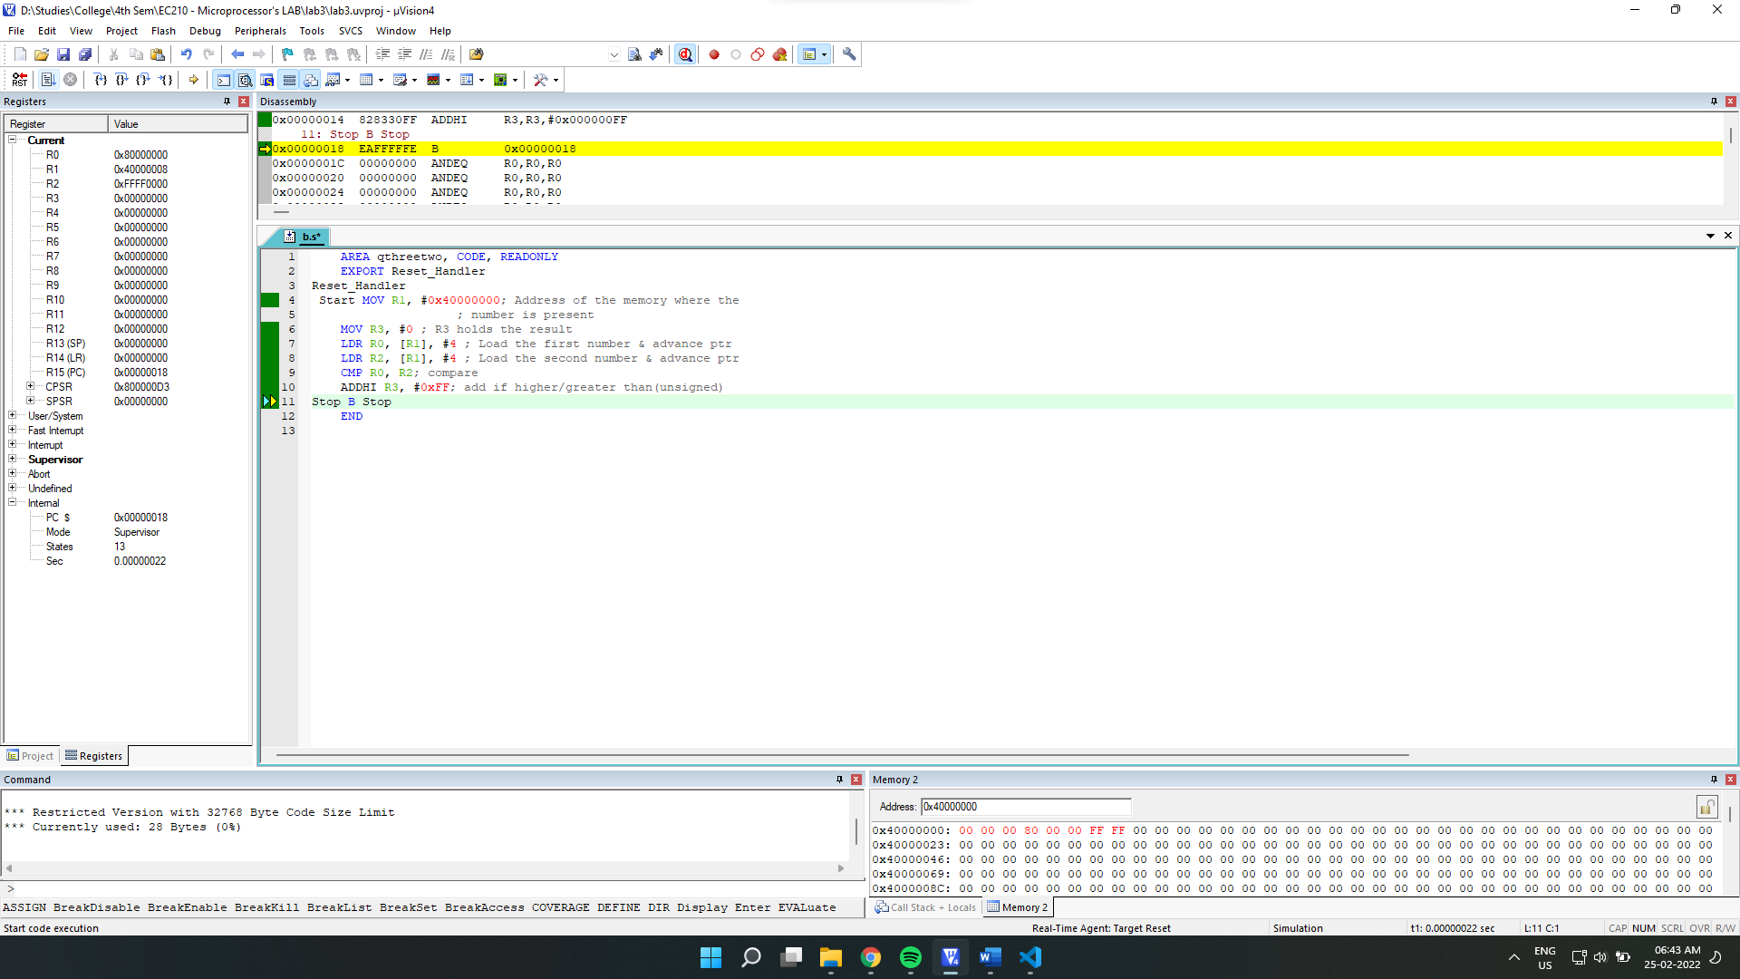

Final Register Values:

